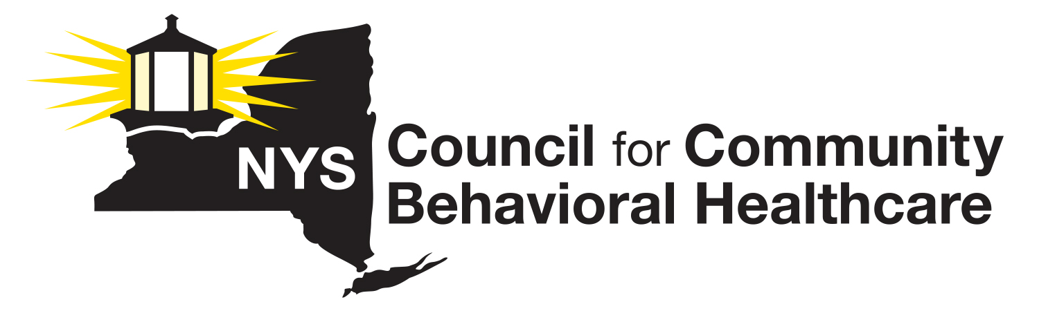
2021 Dues Calculation Worksheet

Please return this completed form, with your 2021 Dues Invoice and payment by January 15, 2021 to:
NYS Council for Community Behavioral Healthcare
Lauri Cole, Executive Director
911 Central Avenue, P.O. Box #152
Albany, NY 12206-3104

Provider Organization

Name of Agency _______________________________________________________________

Address ______________________________________________________________________

Executive Director / Administrator _________________________________________________

Contact Person’s Name (Represents & votes for agency, receives e-mail, faxes, listed in Directory)

______________________________________________________________________________

Contact Person’s phone and e-mail address ___________________________________________

2021 Dues Calculation

The NYS Council annual membership dues formula is based on all mental health and substance abuse services reported on your most recent CFR, ICR (inpatient, outpatient, rehabilitation, residential and community support services). Please attach your schedule as reported as gross budget on CFR, ICR.

Total Budget = $___________________________

Dues Formula:
Members with total budget under $1,000,000 pay a minimum dues amount as follows

Total budget of $500,000 or less $500.00 plus National Council dues
Total budget of $500,000 to $999,999 $750.00 plus National Council dues
Members with total budget $1,000,000 or more pay according to the following dues calculation:

Apply .001 to first $1,000,000 = .001 x $_________ = _____________
+
Apply .0005 to second $1,000,000 = .0005 x $_________ = _____________
+
Apply .0003 to third $1,000,000 = .0003 x $_________ = _____________
+
To everything above $3,000,000 = .0003 x $_________ = _____________

PLUS

2021 National Council Dues = $575.00
(This is a full membership for your agency with the premiere national advocacy organization representing mental health and substance abuse providers in Washington DC: www.thenationalcouncil.org)

= Total Dues $______________________
(total of NYS Council & National Council dues calculation)

DUES EXAMPLES (This example does not factor in National Council dues)
$1,000,000 Budget yields dues at $1,000
$2,000,000 Budget yields dues at $1,500
$3,000,000 Budget yields dues at $1,800
$4,000,000 Budget yields dues at $2,100
$5,000,000 Budget yields dues at $2,400
$6,000,000 Budget yields dues at $2,700
$7,000,000 Budget yields dues at $3,000

(Note: Members with budgets over $2 million pay an additional $300 for each 1 million.)

Example: Agency with operating budget for MH and OASAS totals $9,700,000

Apply .001 to first $1,000,000 = $1,000
Apply .0005 to second $1,000,000 = $500
Apply .0003 to third $1,000,000 = $300
Apply .0003 to $6,700,000 = $2,010
Total dues = $3,810 + National Council dues

**Please round to the nearest dollar.

Now that you have arrived at a Dues Calculation amount,
please use the attached Invoice to send us your payment. Make checks payable to:
New York State Council for Community Behavioral Healthcare
THANK YOU!!

