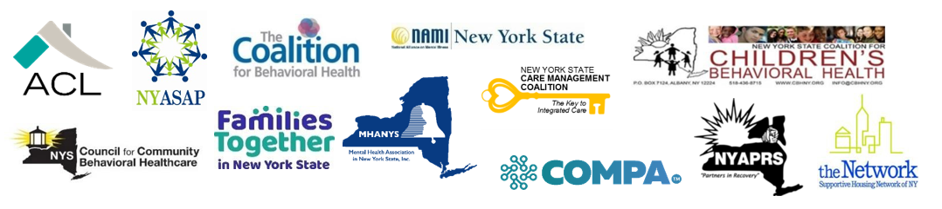

Dear Senate Majority Leader Stewart-Cousins and Speaker Heastie,
Thank you for your continuing leadership and concern for hundreds of thousands of New Yorkers who receive mental health and/or substance use disorder care through the state's public mental hygiene system, and the providers who serve them.
The signatories below are appreciative of the Legislature’s support of funding for our mental health and substance use priorities during budget negotiations which were included in both one-house bills. Today, we want to reinforce the importance of the priority areas outlined below to make certain they are included in the final state budget agreement.
We respectfully ask that the following actions are included in the final budget agreement:
- Full restoration of any/all withholds/cuts to OMH and OASAS providers
- Full restoration of any/all reinvestment funds resulting from bed closures or other ‘rightsizing’ activities as proposed in the executive budget proposal
- Full restoration of the Human Services COLA (1%)

In addition, we remain concerned regarding the future of telehealth services and we request that the Legislature continue to move legislation to ensure the following key components of a strong, telehealth program:
- Rate parity: Telehealth visits should continue to be reimbursed at the same rate as in-person to include audio-only (telephone) modality
- Reimbursement of telehealth services provided by the following staff:
- Certified Peer Recovery Advocates (OASAS)
  - Certified Peer Specialists (OMH)
  - Youth peer advocates certified or credentialed by OMH
  - Family Peer Advocates certified or credentialed by OMH
- Location. Allow patients to receive and providers to engage in telehealth services without restrictions to location.
- Protect Access top Telehealth Services for Dual Eligible Beneficiaries: As a matter of practice, the State does not cover services under Medicaid that are not covered under Medicare when it comes to duals. This is true even if the individual would have received the service if Medicaid was the only insurance coverage. However, in the BH system there is precedent for allowing duals to receive a service that is covered by Medicaid, but not Medicare, because historically Medicare coverage has been very limited. It’s important to continue this approach under telehealth. It might be helpful to add language like this: “for telehealth services not covered by Medicare, Medicaid will cover the full cost of these services for beneficiaries with both Medicare and Medicaid, provided these services would typically be covered by Medicaid.”
Thank you for your continued support and attention to the issues that impact the adults, children and families receiving mental health and substance use services. Should further information be needed, please contact any of the representatives below.

