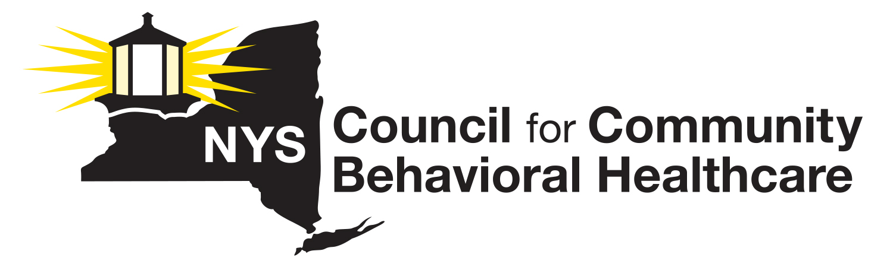
MEMORANDUM IN SUPPORT
S.8416/A.10404-A

An act to amend the public health law, in relation to including audio-
only and video-only telehealth and telemedicine services in those tele-
health and telemedicine services eligible for reimbursement.

The NYS Council for Community Behavioral Healthcare is a statewide non-profit membership association representing the interests of 100 organizations that provide mental health and substance use disorder/addiction prevention, treatment and recovery services to tens of thousands of New Yorkers each day. Our members include free standing community-based agencies, general hospitals, and counties that operate direct services.

The members of the NYS Council vigorously support this legislation, S.8416/A.10404-A, now before the Governor for action. This bill authorizes Medicaid reimbursement for telephonic and tele-video health as reimbursable modality for delivering care.

This bill, if enacted, will validate an effective transformation which occurred in the behavioral health field related to outreach, engagement, treatment, and support of individuals needing mental health and substance use disorder/addiction services during the COVID-19 emergency disaster. Within days of all community activities being cancelled, providers across the state converted their service delivery modalities to include telephonic and tele-video while continuing to provide emergency visits at certain of their clinics. Not only was the transition efficient, but care recipients have acknowledged their increased satisfaction with this option and are pushing hard for the ability to choose telehealth in general, and audio-only or video-only as a service modality on a permanent basis. This is especially true for those concerned with having to return to bricks and mortar settings during this difficult time as well as those who routinely face transportation, financial and other issues that create barriers to access to and continuity of care for some of New York’s most vulnerable citizens.

Our member agencies have struggled mightily with severe workforce shortages for nearly a decade. Providers report high staff satisfaction with the ability to work remotely and they hope to retain this flexibility in the future in order to stabilize their workforce in some way. Our members also report significantly decreased ‘no show’ rates, increased collaboration on treatment plans, and greatly improved engagement.

It is for the reasons outlined above that the NYS Council strongly supports the Governor signing S.8416/A.10404-A into law so that the service delivery improvements that telehealth has brought to our system of care can continue.

June 10, 2020

