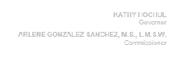
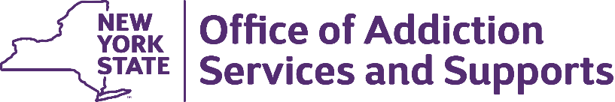

Substance Abuse and Mental Health Services Administration SAPT Supplemental Funding: Fiscal and Program Stabilization

Provider Name: «Provider_Name»
Provider Number: «Provider_number»
SAPT Supplemental Contact Email: «COVID_FUNDS_CONTACT_email_address»

Dear OASAS Provider,

Through the Substance Abuse and Mental Health Services Administration SAPT Supplemental I funding opportunity OASAS is providing fiscal and program stabilization funding to support not-for-profit providers, whether certified or funded, that deliver treatment, recovery, or prevention services as they deal with the on-going ramifications of the COVID 19 pandemic.
Allowable uses for this funding include: operating costs, debt relief, equipment purchases, minor renovations, personnel costs, and other costs related to operations and infrastructure modifications made as a direct result of the impact of the COVID 19 pandemic. These funds must be expended on or before March 14, 2023.
Your provider agency is eligible to receive up to: $ «GRANT_AMOUNT_RND»
Information on scope of work, budget, contracting, and reporting relevant to this funding is available on the OASAS Supplemental Block Grant page at: https://oasas.ny.gov/supplemental-funding-opportunities. See Stabilization Funding Opportunity.
All providers must have a Federal Employer ID Number, register in the Grants Gateway, have an SFS Supplier ID number and have a current Vendor Responsibility Questionnaire on file to contract with OASAS to receive this funding. If these documents/registrations have not been completed, please do so as soon as possible.
Providers receiving this email must submit a detailed budget using the form provided on the webpage to the COVIDFunds mailbox at COVIDFunds@oasas.ny.gov at your earliest convenience.

Any questions related to this communication must be sent to COVIDFunds@oasas.ny.gov, be sure to include your provider number when asking a question.

