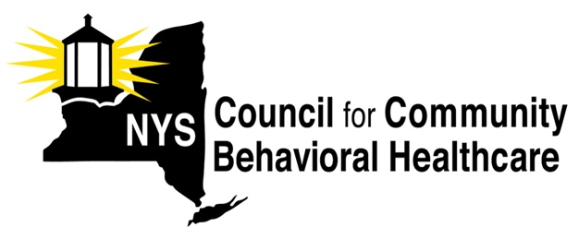

MEMO IN SUPPORT: A6008E/S9449

The NYS Council for Community Behavioral Healthcare is a statewide membership association representing the interests of 112 mental health and substance use disorder/addiction prevention, treatment and recovery agencies located in local communities across New York. Our members provide a broad range of behavioral health services in freestanding non-profit agencies, general hospitals, and through local departments of mental hygiene.

NYS Council members emphatically support A6008E/S9449, ‘same as’ bills that, if enacted, will address a longstanding scope of practice problem that must be resolved prior to the end of the 2022 legislative session to avoid an intensification of already severe workforce shortages across the community mental health and substance use disorder service delivery system. Workforce shortages coupled with the COVID-19 ongoing public health emergency, the ongoing Opioid Crisis, and high rates of suicide in certain populations, have left our agencies desperate for direct care and clinical staff who can meet the challenges associated with increasing demands for care across New York.

The ‘same as’ bills are straightforward, fair and balanced. The legislation adds diagnostic privileges for licensed mental health counselors (LMHCs), licensed marriage and family therapists (LMFTS), and licensed psychoanalysts under Article 163 of the State Education Law. The bills ensure sufficient education, training, and supervised experience for eligible practitioners, and they recognize the skill and expertise of the existing practitioner workforce. As such, the legislation acknowledges the essential tasks and activities these practitioners must be permitted to perform, to ensure timely and appropriate care is available to any New Yorker seeking services through the state’s public mental hygiene system.

The New York State Council urges immediate passage of these bills. We stand ready to assist any lawmaker working to ensure this legislation is enacted before the end of the legislative session.

