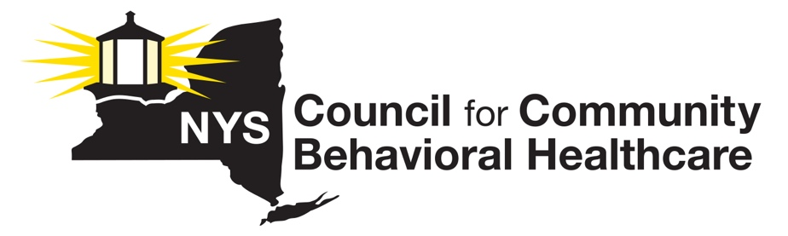
MEMO IN SUPPORT
A9442A (GOTTFRIED)/ S9207 (RIVERA)
Passed Assembly

The New York State Council for Community Behavioral Healthcare (“The Council”) is a statewide membership association representing the interests of 111 mental health and substance use disorder prevention, treatment, and recovery care providers across New York. Our members provide programs and services in a variety of settings including freestanding community-based agencies, general hospitals, and counties, through local departments of mental hygiene.

The NYS Council emphatically supports A9442A/S9207, a bill that would require DoH/OHIP to increase transparency by making public any changes it has made to the state’s Model Contract, a legal document that outlines the contractual requirements on MCOs and the state, in the state’s Medicaid managed care program.
In 2020, the New York State Council sought to ascertain whether the state was enforcing various contractual provisions set forth in the Model Contract that governs the BH Medicaid managed care implementation of 2015. Specifically, we were concerned that MCOs had failed to meet, and the state had failed to enforce performance targets that require plans to spend the vast majority of the funds the plans are paid by the state, on actual care for Medicaid beneficiaries. Through an extensive FOIL process, we confirmed that the state had failed to enforce performance targets that are contractually required of MCOs. We also learned the state had retroactively changed the terms of the Model Contract, without notice to stakeholders who are directly impacted by these changes. The changes had the effect of reducing potential penalties and recoupments on plans by allowing plan expenditures below required performance targets. Allowing underspending due to “effective clinical outcomes” runs counter to the calculation of “savings” from the transition to managed care. Allowing other health plan expenditures not used in establishing the targets is also highly questionable. To date, the changes made by the state in 2020 are not available on the DoH website and stakeholders are largely unaware of the amendments to the Model Contract.
While the recently enacted 2022-2023 state budget returns over $111M in overpayments made to MCOs for two years to impacted state agencies, previous failures by the state to recoup overpayments made to MCOs that failed to meet performance targets have been avoided by MCOs through their lobbying efforts to compel DoH to change performance targets language in the Model Contract.
As stated previously, in 2020, the state made retroactive changes to the Model Contract without a commitment to transparency and despite the fact the changes reduce expectations on MCOs. A9442A/S9207 would require minimal standards of transparency, providing stakeholders and taxpayers critical information about the expectations and requirements MCOs are required to uphold in the state’s Medicaid managed care program, and educating the public as to the state’s responsibilities to enforce contractual requirements, thereby protecting care recipients, providers and taxpayers.
We strongly urge the State Senate to pass this important measure as the Assembly did recently.

