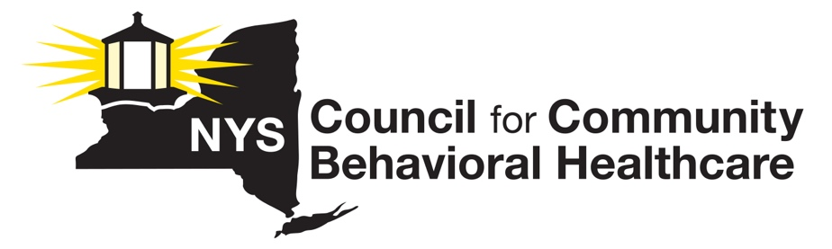
Memo in Support
S6378-A and A7409-A
The New York State Council for Community Behavioral Healthcare (“The Council”) emphatically supports immediate passage of S6378-A, a bill that would permit non-licensed professional staff to assist multidisciplinary teams to implement service plans in programs under the jurisdiction of OMH, OASAS or OPWDD, including services that may be clinical in nature when such staff are under the supervision of a licensed professional.

Specifically, this bill would provide that non-licensed staff in OMH, OASAS and OPWDD programs may assist multidisciplinary teams in the provision of services that may be clinical in nature, when such staff are under the supervision of a licensed professional. The appropriate mental hygiene commissioner would determine such level of supervision. This provision would only apply to such staff hired after June 24, 2022. (Staff hired before this date are permanently exempt from professional scope of practice restrictions, while assisting multidisciplinary teams in Mental Hygiene settings.

Without immediate legislative intervention, the sunset of the clinical practice exemption on June 24 will mean that non-professional staff hired in OMH, OASAS and OPWDD regulated environments will no longer be able to perform the full range of services to persons in need, even when assisting multidisciplinary teams. At present, licensed professionals do not exist in sufficient numbers to fill the need for services, and this assumes a sufficient number of these individuals are even willing to work in the public mental hygiene system.

At a time when the needs for mental health and addiction services have never been greater in New York in part due to the COVID-19 crisis, and at a time of an unprecedented health and mental hygiene workforce crisis, this legislation will allow staff to be hired in these regulated environments, to conduct the type of services that they have been providing for many decades, with the added protection that services that may be ‘clinical in nature’ must be provided under the supervision of a licensed professional.

The absence of this common-sense solution, or the continued extension of the clinical practice exemption, will result in serious negative consequences for New Yorkers in need of life saving addiction and mental health services and will exacerbate the years long workforce crisis in the behavioral health sector.

For these reasons, the NYS Council urges swift passage of this bill before the conclusion of the 2022 Legislative Session.

For further information, please contact Lauri Cole, Executive Director at (518) 461-8200.

