Consolidated Fiscal Reporting System
CFRS Web: Getting Started Guide

Step 1: Click on the link: https://cfrweb.omh.ny.gov/

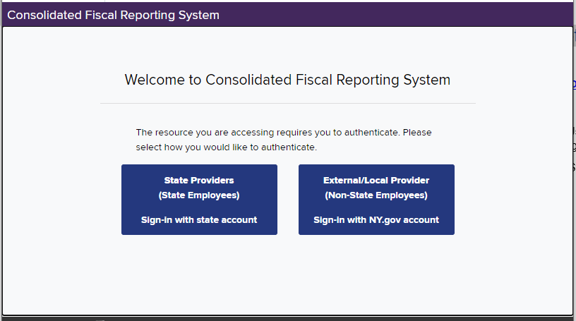

Step 2: Non-State / Provider User - Click on:

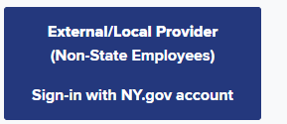

NY State Employee User - Click on:

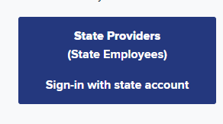
Step 3: Enter the (1) *username, (2)* password and (3) click on the “Sign In” box.

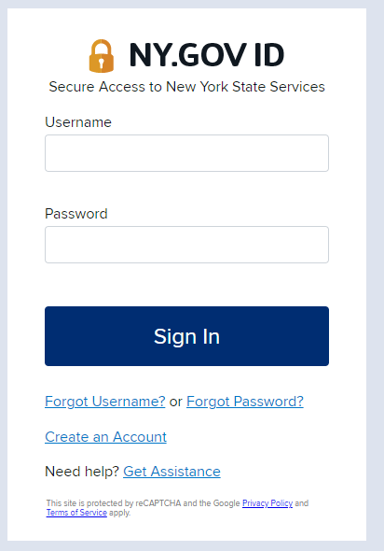

*Non -State / Provider Users -The username and password for CFRS Web was emailed to the user when the Agency’s Security Manager assigned roles for CFRS Web to them in the Security Management System.
NY State Employee User - The employee’s NYS email is entered for the “Username” and the employee’s NYS network password is entered for the “Password”.

Step 4: From the Home Page, a submitted CFR can be reviewed, revised or a new CFR can be created. These functions are dependent on the role that is assigned to the User.

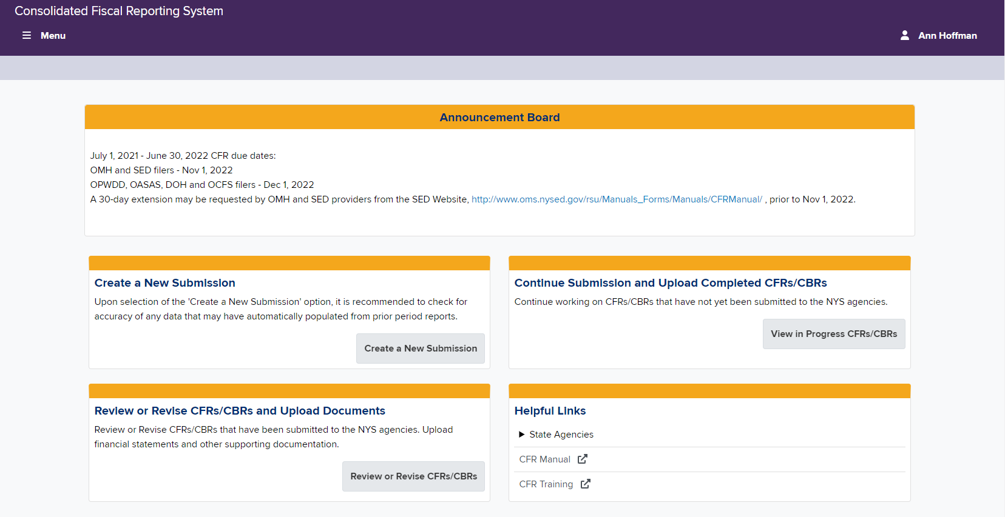

Step 5: Click on the word “Menu” located at the top left corner of the screen for more options.

