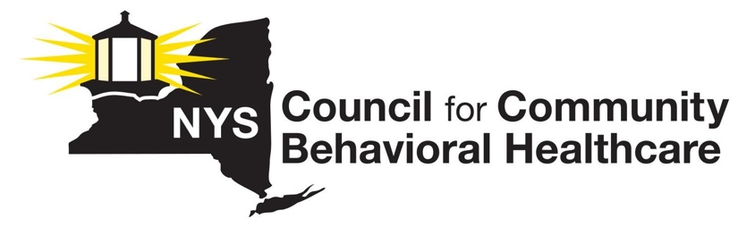

The New York State Council is a statewide membership association representing the interests of 120 mental health and substance use disorder prevention, treatment, recovery, and harm reduction provider organizations and the individuals they serve in local communities across New York.

2023 BUDGET/LEGISLATIVE PRIORITIES

- Reimbursement Reform Recommendations
- Implement COLA @8.5% (July 2022 CPI)
- $500 million investment for MH and SUD providers to create flexible funding. Request is based on decades of underfunding during many years we did not get a COLA
- Implement Outpatient Rate Reform proposal
- Expand federal CCBHC Demo for all eligible NYS Outpatient Clinics
- Address discriminatory reimbursement disparity that exists between what commercial insurers reimburse providers and what Medicaid pays via APG government rates. Commercial reimbursement is often 50% of the state mandated Medicaid APG government rate.)
- Rate increases for Programs and Services that are not sustainable to include: OASAS Part 820 Stabilization and Scattered Living levels of care; OASAS Part 819 Scattered Living levels of care, OASAS Peer Services
NYS Council Member Survey Result: Approximately 50% of survey respondents with commercial contracts receive 50% or less of the Medicaid APG government rate, for the same services.

- Recommendations to Address Workforce Crisis
- Expedite SED Diagnostic Privilege implementation per enacted 2022 law
- Implement Administrative / Regulatory Relief in the pre-employment process required to onboard new employees - often takes months and Central registry looks back 28 years!
-Discontinue discriminatory hiring practices that limit who we can hire (CPS history,
criminal hx
-Implement State hosted Central Registry for clearances and develop a crosswalk for
all state agencies to avoid redundant checks of potential employees and streamline process
- Justice Center must expedite closing unfounded cases in areas of state with significant
Workforce shortages
- Adopt Journeyman approach/accept life experience as relevant job experience
- Temporarily suspend registration fees associated with initial application for and renewal of professional licenses for Mental Health Practitioners
- Scholarship Program for Students Pursuing Mental Health Practitioner Degrees, CASAC,
In a recent statewide survey, we found that the ‘new hire’ rate is nearly identical to the number of
staff that left our employment in 2022.

Recommendations to Address Persistent Medicaid Managed Care/Commercial Insurance Issues
- State must address commercial rate disparity that puts undue pressure on Medicaid APG government rates
- The State must greatly enhance surveillance, monitoring and enforcement activities by OHIP and empower OASAS and OMH to perform more of these tasks
- Need robust access to Medicaid and other data held by health plans for purposes of VBP contracting and other alternative payment methodologies
- Re-negotiate Model Contract language that currently permits MCOs to skirt contractual and other mandated responsibilities
NYS Council Member Survey Result: 1/3 of all respondents’ report that currently they are waiting for delayed reimbursement from an MCO/s. The most frequent response to the question as to how long the agency has been waiting for the payment/s is over 9 months. Range for amount owed to provider is between $10k to $200k.

Recommendations to Support Children, Youth/Families
- CFTSS and HCBS 25% rate enhancement should be made permanent
- Public Health Law should be revised to ensure there are interim intensive supports available in local communities to address instances in which a hospital BH unit/s closes beds/services
- Increase current percentage of federal dollars coming into NYS for children’s system of care to 30%

Recommendations to Support OASAS Primary Prevention Programs and Services
- 10% increase to all OASAS Primary Prevention contracts to address reimbursement that has been stagnant for over 20 years, to assist with workforce shortages, rent increases and operating expenses
- Funds to conduct evaluation of OASAS primary prevention programs
-Develop EBPs for Primary Prevention services
- Current grant cycle (two years) is too short a window to evaluate outcomes
- Funding needed to permit innovation in this service line
- Inability to pay staff at higher wages for weekend and holiday events
- Prioritize primary prevention funds to address increased access to and use of marijuana by youth
- Prioritize primary prevention funds to address increased access to virtual and bricks and mortar gambling venues

For more information about the NYS Council, please contact Lauri Cole, Executive Director at 518 461-8200 or lauri@nyscouncil.org

