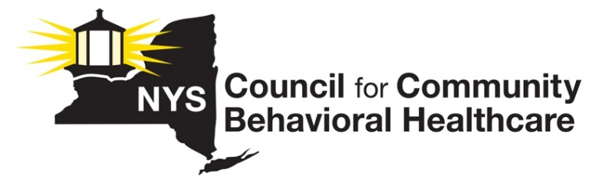
REQUEST
CCBHC FEDERAL DEMO EXPANSION IN NYS
A COST-SAVINGS INITIATIVE THAT BENEFITS NEW YORKERS WITH MENTAL HEALTH AND SUBSTANCE USE DISORDERS and NEW YORK STATE TAXPAYERS

The federal government will soon issue guidance to enable states to open their demonstration programs to more outpatient clinic providers. New York should broadly expand the CCBHC demonstration program and make behavioral healthcare (mental health and substance use disorder/addition care) that is delivered in an integrated model, available to far more New Yorkers.
WHY EXPAND?
The CCBHC Demo Expansion equals increased access to care, reduced costs associated with lower utilization of more acute levels of care, a better model of care for New Yorkers with significant behavioral health conditions, and viability for New York’s Behavioral Health system of care
HISTORY
Since 2017, NYS has participated in a federal demonstration program that implements a new outpatient model of behavioral healthcare called the Certified Community Behavioral Health Clinic (CCBHC) Program. Since then, 13 behavioral outpatient clinic providers across the state have been reimbursed at cost by Medicaid in exchange for adhering to a rigorous set of 115 federally defined standards.

WHAT MAKES THIS MODEL DIFFERENT?
- What distinguishes this program from other efforts to provide behavioral health services to Medicaid beneficiaries is its emphasis on coordinated care across the spectrum of high-quality and accessible behavioral and physical health care; (2) a restructured payment system allowing clinics to deliver high-quality services, and 3) increased access to care.

- CCBHCs must provide at least nine core services, either directly or via formal relationships with partner designated collaborating organizations (DCOs):
- 24/7 Crisis Services
- Treatment Planning
- Screening, assessment, diagnosis, and risk assessment
- Targeted case management
- Outpatient primary care screening and monitoring
- Outpatient primary care screening and monitoring
- Community-based mental health care for veterans
- Peer, family support, and counselor service
- Psychiatric rehabilitation services
CCBHCs must maintain a staffing plan informed by a community needs assessment to ensure centers have appropriate staff to meet the clinical, cultural, and linguistic needs of the service area.
Staff must be licensed, credentialled, and certified and include individuals with training and expertise in treating trauma, SED, SMI, and SUD, such as:
- Psychiatrists / Psychiatric Nurse Practitioners
- Nurses
- Licensed clinical social workers, licensed mental health counselors, psychologists, and addiction counselors
- Community Workers / Case managers
- Peer specialists and recovery coaches
- Community health workers
*CCBHC certification criteria also set standards for staff training in cultural competence; person- and family-centered, recovery-oriented, evidence-based, and trauma-informed care; and primary care/behavioral health integration.
RESULTS

- New York State invested a modest $9.7M/year to achieve these results in Years 1 & 2.

- Based on a financial analysis performed by HMA actuaries for the NYS Council, substantial savings for the state can be achieved with broad expansion of the CCBHC demonstration program across all eligible outpatient clinics. The bigger the expansion, the bigger the savings.

- Conversion of outpatient capacity to CCBHC is budget neutral if New York is receiving the usual 1:1 Medicaid federal match, and CCBHC-D reduces state spending significantly if New York is receiving enhanced CCBHC demonstration match.

