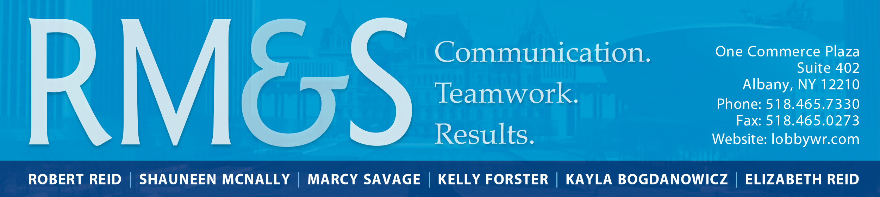

April 30, 2023

This evening four of the final Article VII budget bills have been released (Health/Mental Hygiene, Revenue, Capital and Public Protection). We expect the remaining, final budget bills (both Article VII and Appropriations) to be introduced later this evening and into tomorrow for action by the Legislature early this week if the Governor issues a message of necessity for each. Otherwise, they will need to “age” three days before passage.

Of particular interest to the NYS Council, outlined below is a summary of key provisions of interest from the final Health/Mental Hygiene Article VII bill. Once the Appropriations bills are out we will be able to speak more to individual funding lines and appropriations of interest.

Outline of Final Health/Mental Hygiene Art. VII Budget Bill Provisions of Interest:

Part A: Global Spending Cap: Extended through fiscal year 2024-25.

Part D: Medicaid Prescriber Prevails & OTC Coverage Changes: Rejected.

Part E: Hospital Funding/Provisions: $235.4 million per year from 2023-2025 provided for enhanced safety net hospitals, 7.5% rate increase included for hospitals, provision included on 30-day notice requirements when general inpatient hospitals are planning to convert to rural emergency hospitals to communities, OMH, and OASAS among others.

Part H: Essential Plan Changes: Expands eligibility and moves to 1332 State Innovation Program, establishing new authority and a fund.

Part I: Long Term Care: Includes rate increase for nursing homes and assisted living programs at 6.5%. Includes standards for managed long term care plans.

Part J: Managed Care Reforms to cover hospital services and eliminate prospective denials: Rejected.

Part K: Expand Waiver Eligibility: Extends Medicaid services for incarcerated persons and those in institutions of mental disease (IMDs).

Part L: Site of Service Review: Provisions included.

Part P: Healthcare Facility Transformation Program, Statewide V: Includes language consistent with Executive Budget to provide up to $490M without competitive bid for grants, capital and other projects by eligible health providers and up to $500M without competitive bid for health technology and telehealth transformation projects.

Part Q: Scope of Practice: Most proposals in Executive Budget rejected exemption final budget includes expansion of services by community health workers and reimbursement for LMHCs and LMFTs for certain services at Medicaid APG rates.

Part R: Medicaid Coverage of Prevention Services: Retains provisions to cover nutritionists and dietician services and chronic disease management services.

Part Y: Medical Debt/ Health Insurance Guaranty Fund: Rejects drug price increase reporting proposal, retains hospital medical debt requirements, uniform financial assistance provisions and requirement for NY health insurers to have health guaranty fund.

Part AA: Preventable Epidemics: Retails provisions regarding routine offering of Hep C screening to those over 18, those under 18 at risk, pregnant people and also screenings for syphilis for pregnant people.

Part BB: Ban on Fentanyl Analogs: Included.

Part CC: Shift Oversight of Health/MH Professions to DOH: Rejected.

Part DD: COLA: Increases COLA to 4% (from 2.5%) for 4/1/23-3/31/24.

Part GG: Qualified Mental Health Associate Credential: Rejected.

Part HH: CCBHCs:
- CCBHC Expansion: Executive Budget Medicaid scorecard provides $19.7M over two years to expand to 39 CCBHCs (no Article VII language included).
- Includes joint certification proposal for CCBHCs by OMH and OASAS.
- Includes CCBHC Indigent Care program funding consistent with Executive Budget ($22.5M 7/1/23-6/30/24; $41,250,000 7/1/24-6/30/25; $45M 7/1/25-6/30/26 gross with federal share if approved).
- Additional language included around criminal history review and Justice Center with CCBHCs.

Part II: Commercial Insurance-BH:
- Subpart A: Crisis Stabilization/ Mobile Counseling Services/ School Based Mental Health services. Final budget includes commercial insurance coverage requirements within 30 days of hospital discharge, includes additional definitions of these services and accepts provisions on school based mental health clinic reimbursement on negotiated or Medicaid rates regardless of whether they are a participating provider with insurer.
- Subpart B: No Preauthorization/Concurrent Utilization Review for certain BH services (in network hospital, crisis residence) included. Does not include requirement for one tool to be used per OMH.
- Subpart C: Telehealth parity- rejected.
- Subpart D: Private Right of Action for Parity violations- rejected
- Subpart E: Insurance Coverage for SUD meds without prior authorization included.
- Subpart F: Network Adequacy standards, APG floor rate for out of network care. This is modified significantly to just call on Superintendent of DFS, in consultation with OMH and OASAS to develop regulations to set network adequacy standards for SUD/MH by December 31, 2023. Does not include APG rate floor provision.
Part JJ: Penalties for Mental Health Law Violations: Included.
Part MM: New Proposal on Insurance Clinical Peer Reviewer Standards: Includes proposal per one house budgets to update insurer clinical peer reviewer standards including additional standards for determinations involving SUD treatment to have a license to practice medicine, specialize in BH and experience in the delivery of SUD treatment. And for the purpose of determinations re: MH treatment, have a license to practice medicine, specialize in BH and experience in delivery MH treatment.
Part NN: New Proposal provide home care rate increases.
Part OO: New Proposal creating Daniel’s Law Task Force: Creates a 10-member task force established by OMH and OASAS to look at the effectiveness of crisis response and diversion services and to issue recommendations for expansion by 12/31/25.
Part PP: New Proposal creating Maternal Mental Health Work Group: Creates a workgroup within OMH to study and issue recommendations related to material mental health, perinatal and post-partum mood and anxiety disorders. Report with recommendations to be issued by 12/31/24.
--

