May 24, 2023

New York State Office of Medicaid Inspector General
800 North Pearl State
Albany, NY 12204

On behalf of our organizations and respective associations below, we submit this testimony to the Office of the Medicaid Inspector General’s Office (OMIG) regarding OMIG audit practices and their impact on New York State Medicaid providers. This testimony reflects the experience of many sectors providing care and services, many to New York’s most disinvested communities, disproportionately impacted by negative health outcomes.

Although we respect and understand the important role the OMIG provides in assuring New York’s Medicaid program’s resources are spent responsibly and in line with the federal and state Medicaid rules and regulations, it is equally imperative that audits do not hamper the ability for quality Medicaid services to be delivered. Current OMIG practices are not only administratively onerous and time consuming, taking valuable time away from delivering care; but the practice of extrapolating clerical errors into disproportionate findings is crippling and risks sustainability of the system.

To address this tension, our organizations worked in partnership with legislative leaders to pass legislation last year, while supporting OMIG’s important role in assuring the Medicaid program’s integrity and also assuring providers are not overly penalized for clerical and/or administrative errors. Therefore, it was a great disappointment and concern that Governor Hochul did not join us, despite unanimously passing both Houses, and vetoed the 2022 OMIG Reform Bill (S.4486/A.7889-A). The Governor’s veto message explained that she was concerned that the bill would constrain the OMIG from fulfilling its state and federal responsibilities of ferreting out fraud and abuse in the Medicaid program – an important matter for all of us.

Nevertheless, the Governor recognized providers’ concerns regarding overzealous audits and instructed the OMIG to:

(1) Engage the provider community.
(2) Review the agency’s processes and identify areas for improvement.
(3) Consider the financial impacts on providers and commit to program integrity activities that “assures continuity of care for Medicaid recipients.”
(4) Assess opportunities to report on provider requests for financial hardship and the impacts of enforcement actions.

On February 21, 2023, provider associations representing a broad range of New York’s Medicaid providers and advocates met with the Executive and the OMIG in an initial attempt to address these problems. The associations were informed that the OMIG would be holding stakeholder meetings across the state.

We cautioned the OMIG that their plan would not engage the provider community because of the inherent imbalance of power in their proposed meetings. Due to OMIG’s audit practices, we understood a provider’s fear of OMIG’s retribution would prevent a provider from speaking openly and truthfully about their concerns with OMIG and their practices. In response, OMIG established a way for providers to submit anonymous comments, but unfortunately, many providers still feared retribution from OMIG and have opted not to share their experiences.

The 2023 Provider Engagement Sessions have failed to provide a forum that engages the community. Rather, most of the listening sessions were a presentation by OMIG on their role, setting a difficult tone to engage productively engage providers. This response to the Governor’s veto instructions was particularly disappointing.

A new OMIG Reform bill, S.5329-A (Harckham)/A.6813(Paulin) has been introduced. S.5329-A/ A.6813 addresses the Governor’s concerns regarding the state’s ability to collect overpayments and the resulting state liability for any federal share of those overpayments, while also assuring that an already stretched and understaffed Medicaid provider community is not inappropriately burdened. While we work toward the passage of the new bill, we welcome the partnership of Governor Hochul and the OMIG in support of this measure.

2023 Legislation

OMIG Audit Protections/Best Practices in S.5329-A/A.6813 include:
- Defines Overpayments and Limits Extrapolation: Includes a definition for overpayment and includes standards for when extrapolation may be used for overpayments consistent with federal CMS standards including a “sustained or high level of payment error of 50% or greater,” identical payment errors were found in a prior audit, provider was previously sanctioned for identical payment errors, or similar.
- Notice and Recovery Timeline: Requires that recovery of an overpayment must not take place until at least 60 days after issuance of a final audit report, or if a provider requests a hearing within 60 days of receiving final audit report, not until a final determination is made.
- Repeat Audits: Prohibits the repeating of a review or audit within the last three years of the same contracts, cost reports, claims, bills, or expenditures unless OMIG has new information, good cause to believe the previous audit was erroneous, or a significantly different scope of investigation.
- Regulations in Place of Time of Claim/Conduct: Requires OMIG to apply the laws, regulations, policies, guidelines, standards, and interpretations of the appropriate agency that were in place at the time the claim or conduct occurred.
- Correction of Administrative or Technical Defects: Requires OMIG to inform the provider of an error and gives 60 days from notice of the mistake or 6 years from the date of service for provider to correct it and resubmit claim, as long as certain standards are met by provider.
- Draft Audit Findings: Requires OMIG to provide a detailed written explanation of the extrapolation method used at the exit conference or in a detailed written explanation of any draft audit findings given to the provider.
- Statistically Valid Extrapolation Method: Requires that OMIG may only use statistically, reasonably valid extrapolation methods for audits where extrapolation is permitted. Such method shall be established in regulations of the OMIG.
- Compliance Programs: Requires the OMIG to notify a provider if their compliance program is not satisfactory and allows the provider 60 days to submit a proposal for a satisfactory program and adopt expeditiously.
- Annual Report to Consider Audit Impacts on Medical Services: Requires the OMIG to consult with the Commissioner of the New York State Department of Health (DOH) when preparing and filing its annual report on the impacts that all civil and administrative enforcement actions, taken in the prior year, have had or will have on the quality and availability of Medicaid services. The report shall also address the fiscal solvency of the providers subject to enforcement actions.
- Applicability to All Medicaid Audits and Those Conducting Audits: Applies standards to audits under both Medicaid fee for service and managed care and applies to anyone lawfully authorized to conduct an audit.
- Federal Audits: Includes a clause that the provisions of the bill will be interpreted consistent with federal requirements.

Thank you for your consideration of this important information and request. We look forward to working with you to ensure the integrity and sustainability of New York’s Medicaid system and services.
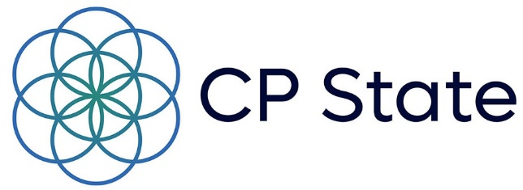
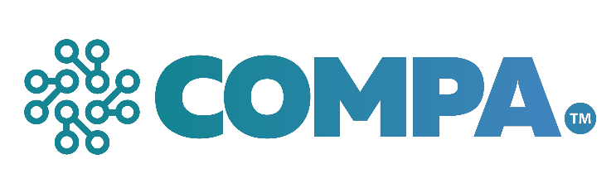

Barbara Crosier
Cerebral Palsy Associations of NYS (CP State)

Allegra Schorr
COMPA

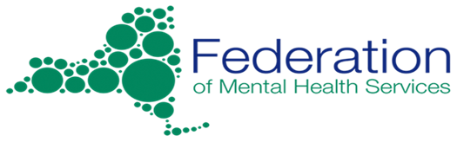
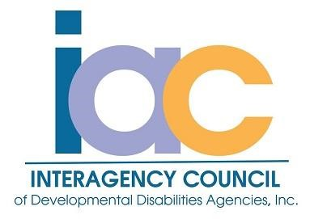

Tracy Schneider
Federation of Mental Health Services

Winifred Schiff
InterAgency Council of Developmental Disabilities Agencies

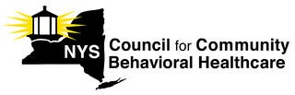
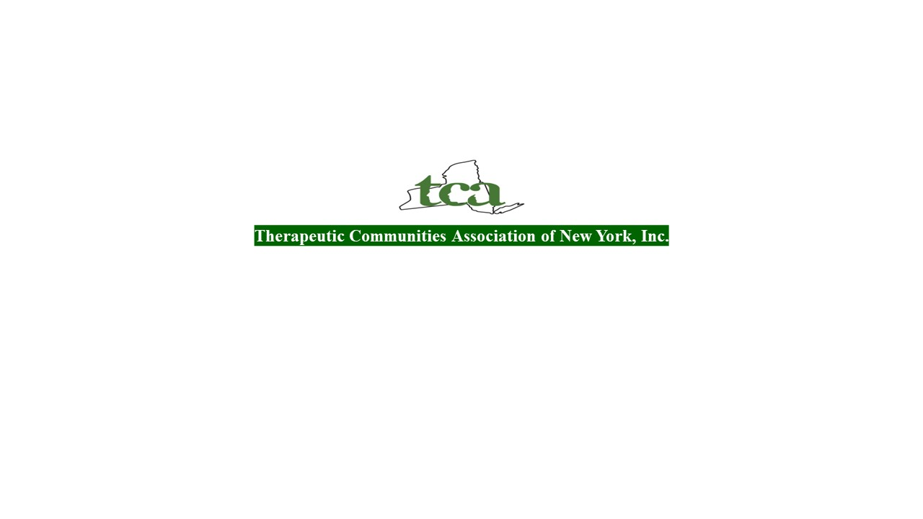

Norwig Debye-Saxinger
Therapeutic Communities Association of New York, Inc.
Agencies
Winifred Schiff, InterAgency Council of Developmental Disabilities Agencies

Lauri Cole
New York State Council for Community Behavioral Healthcare

