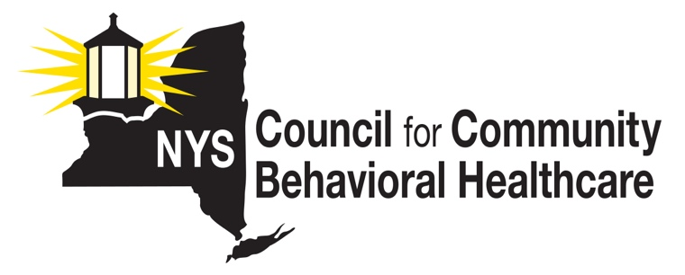
’23 - ‘24 State Budget & Legislative Outcomes

- 4% COLA

- CCBHC Demo Expansion from 13 to 39 by July 1 2025 (13 in 2024; 13 in 2025)

- CCBHC Indigent Care Pool Implementation ($22.5M in FY 2024 and
$41.3M in FY 2025 w/ CMS SPA required from NYS by 9/30/23)

- 25% rate increase for school-based MH clinic services (effective 10/1)

- Additional Article 31 Outpatient Capacity (TBD)

- $37M MCO recoupment of overpayments OASAS (this began in 2019-2020 and is recurring at differing amounts) resulting in rate increases for most OASAS programs and services this year (pending)

- $74M MCO recoupment of overpayments OMH (this began in 2019-2020 and goes forward at differing amounts) resulting in rate increases last year (implemented)

- Network Adequacy language to require new requirements for MCOs

- Hospital Rate Increases (Inpatient = 7.5%; Outpatient 6.5%)

- Increase thresholds for OMH/OASAS agencies that want to deliver more of the ‘other’ services w/out having a license to do so (pending)

- SUD Commercial insurance coverage for SUD Treatment and Medications

- Re-constitute DoH/OMH/OASAS Integrated Care Workgroup (pending)

- Language expanding state-regulated commercial insurance coverage of sub-acute care in a medically monitored residential facility under OMH, outpatient care provided by crisis stabilization centers and outpatient care provided by a mobile crisis intervention services provider, critical time intervention services and assertive community treatment services.

CCBHC Demo Expansion:
An RFP is being developed for approving 13 new CCBHCs, with plans to release soon
Awards targeted for 1/1/24 allowing 6 months for program development, with “launch” of first 13 new CCBHCs on July 1, 2024, and second RFP out late ’23 w/ implementation July 1, ’25.

