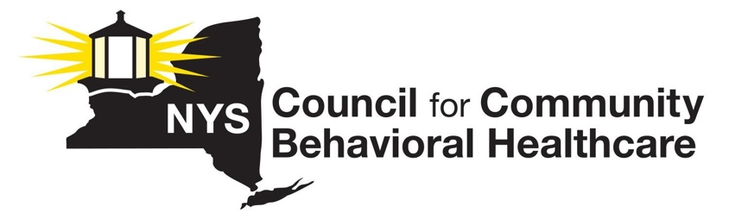

NYS Council Regulatory Reform Workgroup – Meeting #2

August 9, 2023

Summary of Meeting:

The meeting began with a quick review of last week’s discussion and direction from the group. We differentiated between Regulatory Reform, Regulatory Relief, and Regulatory Modernization.

A recurrent theme was the challenges presented by providers having to follow multiple state agency regulations that are sometimes redundant and at other times diametrically opposed. This is particularly true for regulations required by Department of Health (DOH), OASAS and OMH. It appears there is a lack of vested power in the state agencies that must often defer to DoH that does not always reflect a deep understanding of behavioral health issues and concerns.

Participants emphasized the importance of distinguishing between reform, relief, and modernization. The discussions pointed towards the need for more streamlined processes, especially in licensing. The burden of excessive documentation and administrative hurdles was a significant concern, particularly for smaller providers. The mention of "system transformation" suggests a more holistic change in the way services are provided and regulated. They further elaborated on the difficulties faced in navigating the complexities of regulatory systems and the potential benefits of modernizing these systems.

The group is fully behind our agreement to propose language to the Executive to establish a new commission, to rapidly address necessary regulatory relief in the face of two public health crises and the ongoing workforce crisis. The Commission would be empowered by the Governor to address acute needs similar to the way in which the state recently exempted potential state workers from having to take the state civil service exam. Learning from previous commissions put in play by the executive will be important.

The Justice Center's impact on efficient and effective programs and services was discussed extensively. Concerns about allegations of mistreatment, the center's alleged "chilling effect" on reporting, and the implications of its annual reports were prominent discussion points.

Clinic safety, particularly in the face of violence, became a focal point. Discussions centered on the increasing incidents of violence in clinics, street attacks, and the overarching safety concerns this poses for both staff and patients.

Other regulatory concerns experienced by the workgroup that should be prioritized by the workgroup include topics this workgroup wants to prioritize include the trend towards siting of outpatient and methadone clinic. The Certificate of Need and PAR processes require reform with more power vested with the state agencies concerning decisions regarding siting and we agreed that in the longer term, we must address the NIMBY (Not In My Backyard) issue, and we will work to push for strengthened anti-NIMBY regulations.

Workforce challenges, including the dynamics of employee roles, associated laws, and licensing requirements, were addressed. Modern healthcare practices, budgetary constraints, and the importance of staffing adequacy in hospitals and clinics were also significant points of discussion.

Throughout the meeting, there was a clear emphasis on collaboration, the need for efficient processes, and the importance of ensuring that reforms and strategies align with current and future healthcare demands.

**Action Steps:**

* Formulate and present language to the governor's office advocating for the establishment of a new commission to make expedited recommendations for Regulatory Relief. Previous Commissions as a Reference: Several participants brought up the idea of using language and strategies from previous commissions as a template for current endeavors. This retrospective approach could serve as a foundation for crafting new proposals and strategies.
* Prioritize the streamlining of licensing processes, ensuring they are robust yet agile
* Engage smaller providers to understand and subsequently alleviate their administrative burdens.
* Push for enhance coordination among state agencies to align with broader reform objectives.
* Regularly review and adapt workforce roles and licensing requirements to reflect evolving needs and challenges.
* Continuously assess the implications of Justice Center allegations, ensuring that responses are both compassionate and data driven.
* Amplify safety measures across clinics, with a particular emphasis on reducing the risk of violence and street attacks, and where possible press for indemnification of staff-bystanders who are intervening when a colleague/fellow staff member is facing immediate risk posed by a care recipient.

**Long term next steps:**

Streamlined Licensing Process: Beyond immediate reforms, there's a need for an ongoing evaluation and refinement of the licensing processes to ensure they stay relevant and efficient in the face of evolving healthcare and public service demands.

Safety Protocols in Clinics: The discussions around violence in clinics highlighted the necessity of longer-term work to establish and routinely update comprehensive safety protocols. This includes staff training, infrastructure upgrades, and community outreach to ensure the safety of both staff and patients.

State Agency Collaboration: The challenges discussed about state agencies not aligning perfectly call for a long-term strategy for inter-agency collaboration, regular communication, and shared objectives.

Ongoing Assessment of Workforce Dynamics: As healthcare and public service landscapes evolve, there's a continuous need to assess and adapt workforce roles, licensing requirements, and training programs.