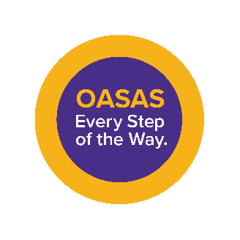

SCHOLARSHIP OPPORTUNITY
AVAILABLE NOW!

We are pleased to announce that the New York State Office of
Addiction Services and Supports (OASAS) will provide full
scholarships to community-based organizations to complete the
350-hour Credentialed Alcoholism and Substance Abuse
Counselor (CASAC) program and/or the 50-hour Certified Recovery
Peer Advocate (CRPA) program online. Bilingual/multilingual
individuals are highly encouraged to apply. Please contact those listed
below to obtain additional information about these exciting educational and
scholarship opportunities. Applications are being accepted on a continuing basis
until all scholarships are awarded.

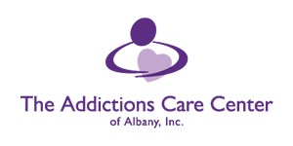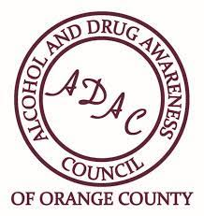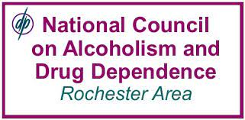
CASAC 350-hour Scholarships CASAC 350-hour & CRPA 50-hour CASAC 350-hour Scholarships
Scholarships
Contact: Michael Barbarulo at Contact: MaryAlice Kovatch at Contact: Jennifer Faringer at
mbarbarulo@theacca.net sas@adacinfo.com jfaringer@depaul.org

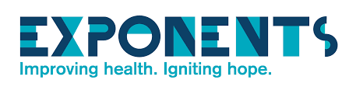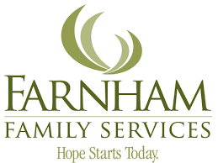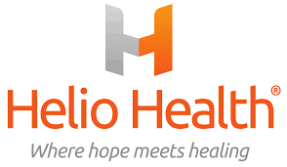
CASAC 350-hour & CRPA 50-hour CASAC 350-hour Scholarships CASAC 350-hour & CRPA 50-hour
Scholarships Scholarships
Contact: Tawana Rowser-Brown, PhD Contact: Megan Walradth at Contact: Nathan Rauscher at
at tbrown@exponents.org MWalradth@farnhaminc.org Training@Helio.Health

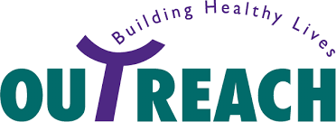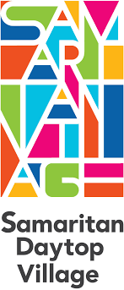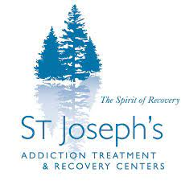
CASAC 350-hour Scholarships CASAC 350-hour Scholarships CASAC 350-hour Scholarships
Contact: Anthony Pereira at Contact: Tania Ruffin at Contact: Ruby Holleran at
anthonypereira@opiny.org Tania.Ruffin@samaritanvillage.org Rholleran@stjoestreatment.org

ELIGIBLE APPLICANTS:
- New York State residents who are at least 18 years of age with a minimum of a high school diploma or a high school equivalency (HSE) from an accredited institution and who are employees of one of the following (OASAS, OMH or DOH programs below will be prioritized to receive scholarships):
  - OASAS-certified, funded, or otherwise authorized programs;
  - OMH- and/or DOH-certified Integrated Outpatient Services (IOS-SUD); or
  - DOH Drug User Health and/or Harm Reduction programs.
- After priority populations, the following will also be eligible:
  - Individuals working within the addictions field (prevention, treatment, recovery, and/or harm reduction) in an eligible non-OASAS setting such as OMH and DOH programs not listed above and
  - Individuals or students interested in working in eligible OASAS, OMH or DOH settings.

