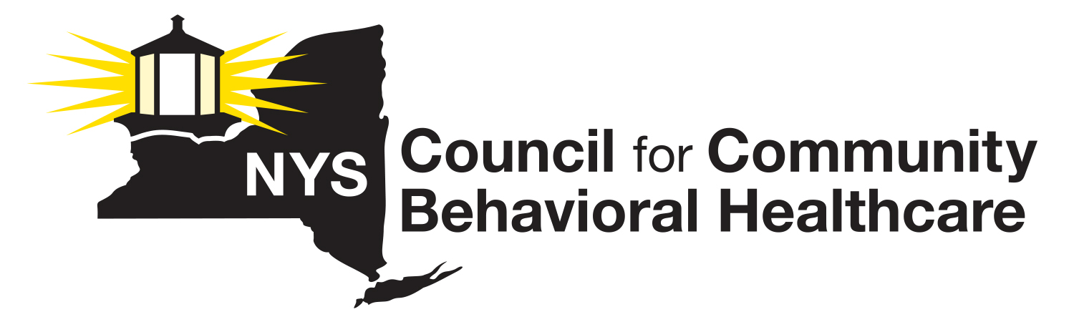
2025 Annual Membership
Dues Invoice

Invoice Item: 2025 Annual Membership Dues

Please enter your 2025 NYS Council Dues Calculation amount in the blank space (below). This amount should be calculated based on the instructions supplied with the 2025 Dues Calculation Worksheet.

Please note: NYS Council Dues are due by February 1, 2025. If you need to make alternate arrangements, please contact Lauri Cole at (518) 461-8200 at your earliest convenience.

Agency Name ______________________________________________________________

2025 Dues Payment $________________________________________________________

Please make all checks payable to the NYS Council for Community Behavioral Healthcare.

Send your 2025 dues payment along with a copy of the completed invoice and a completed Dues Calculation Worksheet to:
Lauri Cole, Executive Director
NYS Council for Community Behavioral Healthcare
911 Central Avenue, P.O. Box #152
Albany, NY 12206

Questions? Call Lauri Cole, Executive Director, NYS Council at (518) 461 8200.

Thank you for your support!

