

Fiscal Policy Institute Briefing: New York’s Response to Federal Budget
Nathan Gusdorf, Executive Director for the Fiscal Policy Institute, State Tax/Budget Think Tank
July 17, 2025

- Impact of the One Big Beautiful Bill Act “OBBBA” (see last week’s FPI briefing summary included in 7/11/25 RMS End of Week for more info). FPI estimates total cuts to amount to ~$10 billion, itemized in the chart below. The State’s own estimate is a $750 million cost in the current fiscal year. FPI anticipates the recurring cuts to grow to $8 billion annual costs once all elements of OBBBA are phased in.

- How can lawmakers respond?
  - Extraordinary legislative session: This year’s funding reductions are not so serious that they require new budgetary discussions. The state currently has about $31 billion in financial reserves. Next budget session will bring bigger shortfalls that must be confronted.
  - Governor’s emergency powers: The special authorities granted in the FY 2026 budget may be utilized although, it does not appear the $2 billion threshold will be triggered this year.

- Federal Tax Policy
  - The current federal tax cuts are deficit-financed and are almost entirely extensions of current tax rates
  - In 2017, the Tax Cuts and Jobs Acct enacted major tax cuts for most taxpayers, at a deficit cost of $1.5 trillion, enacting various tax cuts (reduce corporate tax rate, cut income tax, SALT cap, etc.) which were set to expire at the end of 2025 due to budget reconciliation rules.
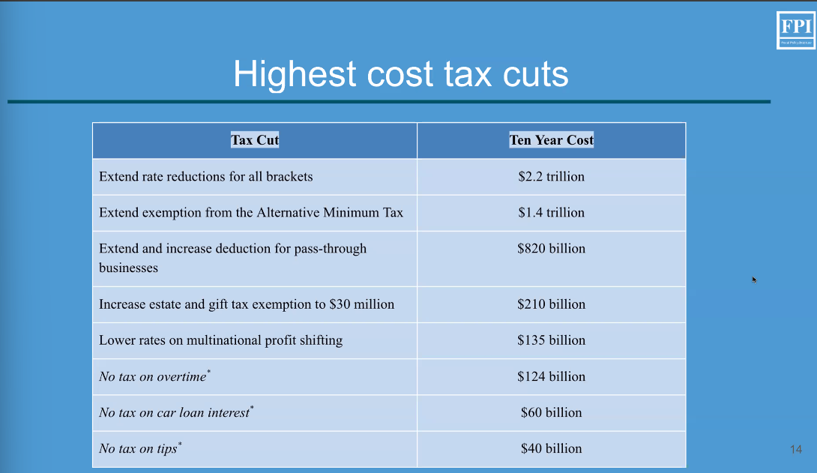
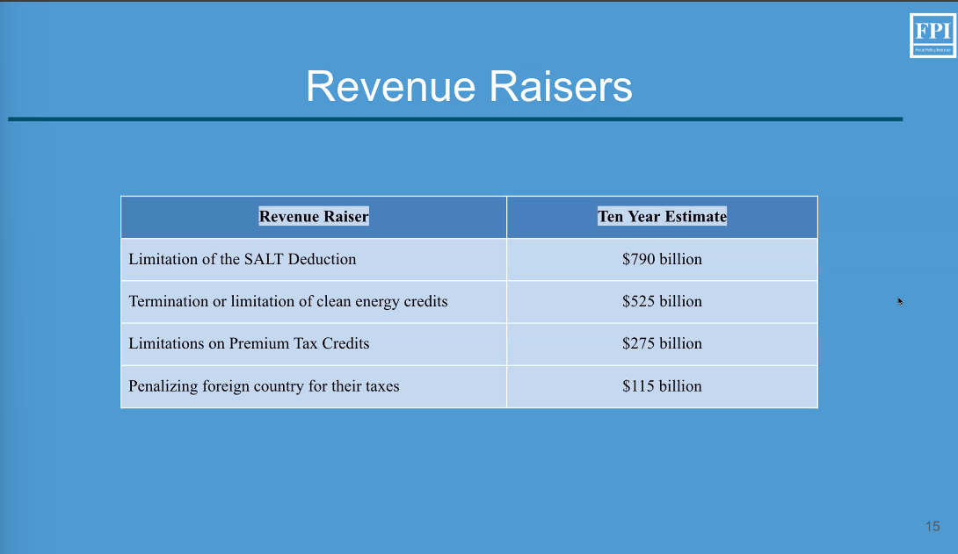
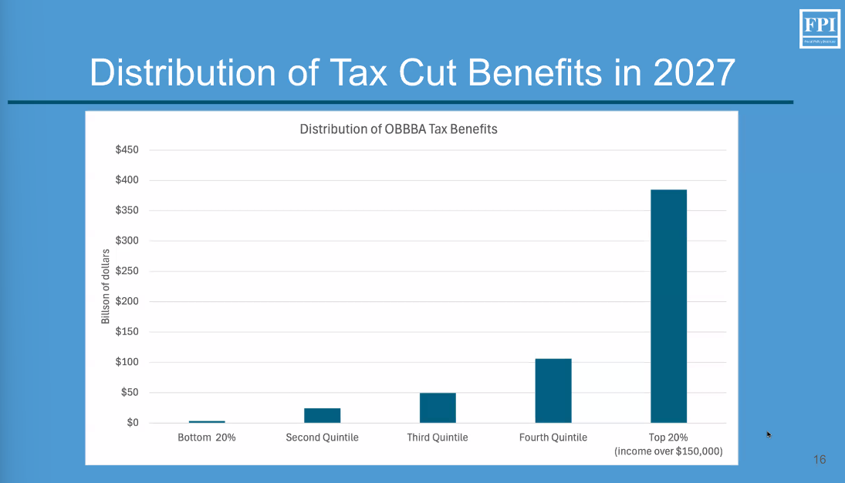
- What does this mean for NY?
  - NY’s total state economic activity (gross state product) was $2.3 trillion in 2024.
    - State tax revenue: $148 billion
    - NYC tax revenue $87 billion
    - Other local tax revenue: $65 billion
  - There are only a few tax bases that yield substantial revenue, especially at tax rates low enough to be non-distortionary
    - Consumption
    - Income
    - Corporate profits

- FPI Recommendations
  - Raise the personal income tax by 1% on ALL taxpayers earning over $250,000: generates $5 billion annually
  - Impose a sales tax on services at 1%; generates $5-6 billion annually
  - Tax pass-through businesses like corporations generates $9 billion annually

- Q&A
  - There was a question about the stock transfer tax, what are the arguments against doing it, and how much would it bring in?

FPI responded that the stock transfer tax presents several concerns including that today's high frequency trading is not conducive for accurate tax estimates nor quantifying the potential impact on NY businesses. Implementing in NY only would disproportionately impact NY businesses, likely forcing them to relocate out of state. Further, it's hard to quantify what the effects of taxing every single trade will be on businesses. The estimated $14 billion dollar revenue from a stock transfer tax is likely inaccurate due to how difficult it is to estimate high frequency trades. The appeal of adopting a broader based tax approach is higher predictability and no need to worry about potential distortionary effects of a stock transfer tax given extreme variability.

