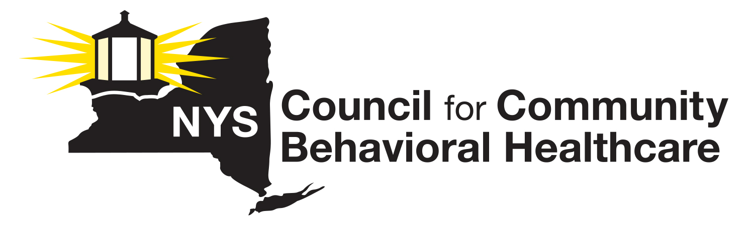
2026 Annual Membership
Dues Invoice

Invoice Item: 2026 Annual Membership Dues

Please enter your 2026 NYS Council Dues Calculation amount in the blank space (below). This amount should be calculated based on the instructions supplied with the 2026 Dues Calculation Worksheet.

Please note: NYS Council Dues are due by February 15, 2026. If you need to make alternate arrangements, please contact Lauri Cole at (518) 461-8200 at your earliest convenience.

Agency Name ______________________________________________________________

2026 Dues Payment $________________________________________________________

Please make all checks payable to the NYS Council for Community Behavioral Healthcare.

Send your 2026 dues payment along with a copy of the completed invoice and a completed Dues Calculation Worksheet to:
New York State Council for Community Behavioral Healthcare
c/o Lauri Cole, Executive Director
911 Central Avenue, #152
Albany, NY 12206

Questions? Call Lauri Cole, Executive Director, NYS Council at (518) 461-8200.

Thank you for your support!

