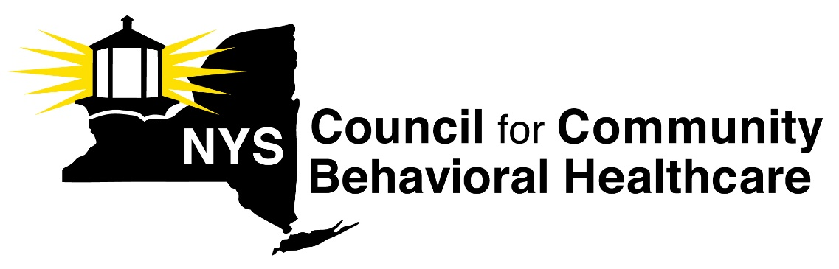

To: Karen Madden, Director Center for Health Care Policy and Resource Development, NYS DOH
From: Lauri Cole, Executive Director, New York State Council for Community Behavioral Healthcare
Re: Rural Health Transformation Program Proposals
Date: September 19, 2025
The New York State Council for Community Behavioral Healthcare (The Council) is grateful for the opportunity to submit proposals for the Rural Health Transformation Program (RHTP) to the State of New York Department of Health. As the representative of 170 organizations providing behavioral health care to over 1 million New Yorkers, The Council’s north star is, was, and always will be access to quality behavioral healthcare for any New Yorker who needs it.
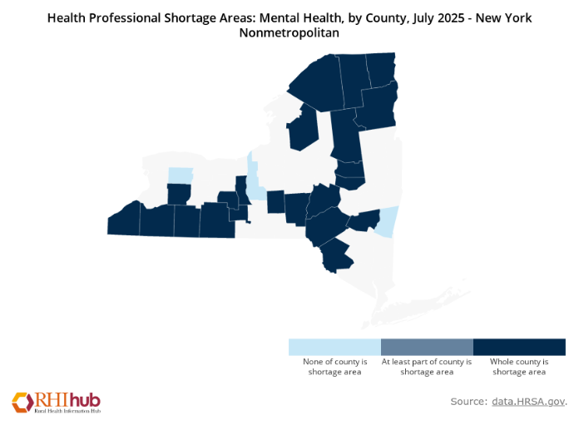
Like the rest of the United States, New York State is undergoing a behavioral health workforce crisis. Mental health professional shortage areas (MHPSA) in New York State are persistent—48 of New York’s 62 counties are at least partial MHPSAs. Rural areas bear the brunt of shortages. More than 87% of all state land in New York is considered rural, and nearly 3.4 million New Yorkers (18%) live in rural parts of the state.
There are 22 rural, or “non-metropolitan” counties where the whole county is a shortage area. A recent report from the Office of the New York State Comptroller examining a selection of sixteen rural Counties noted that rural New York faces the most severe mental health professional shortages. In rural NY, the ratio of mental health practitioners per 10,000 residents is 6.9, less than half the ratio for the rest of the state (16.1). Over 305,000 people across the sixteen counties with MHPSAs in the OSC report, or nearly 41% of the total population of the area, have been designated by HRSA as medically underserved.
Figure 1: There are 22 non-metropolitan counties in NY in which the whole county is a MH Professional Shortage Area
Rural mental health shortages contribute to significant disparities in the ongoing health of communities. Suicide rates are 2x higher than in urban areas, and suicide among farmers is 1.5x the national rate. Compared to their urban peers, rural children have increased risk for mental, behavioral, or developmental disabilities, rural women are depressed at twice the rate of urban women, rural older adults have higher rates of depression, suicide, and alcohol misuse. Furthermore, rural veterans are 70% less likely to receive mental health treatment, and rural residents are more likely to be uninsured, underinsured, or be Medicaid beneficiaries.
As a result of these profound access challenges in rural areas and the concomitant poor outcomes, The Council convened our members to identify opportunities to improve access to behavioral healthcare that are consistent with the requirements of the Rural Health Transformation Program. These providers, who have been serving on the front lines of our rural behavioral health crisis, identified seven opportunities for New York state to improve access in their communities:
- Rural CCBHC expansion to improve access to integrated behavioral healthcare
- Rural behavioral health data exchange fund to improve access to coordinated care
- Rural behavioral health workforce incentive fund to improve access to qualified care providers
- Rural behavioral health quality improvement fund to improve access to quality care
- Hubs for medication for opioid use disorder and long-acting injectable antipsychotics to improve access to pharmacological care
- eConsultation Program for rural community-based behavioral health providers, rural community health centers, and rural hospitals
- Mobile behavioral health clinics to improve access to on-site care
The Council and our members are committed to New York’s successful implementation of the Rural Health Transformation Program. We are available to answer any questions, clarify any of our proposals, and support the department any way we can. Please reach out to me at 518-461-8200 or lauri@nyscouncil.org.

Rural Certified Community Behavioral Health Clinic (CCBHC) expansion

CMS Focus Area: Improve access to integrated behavioral health care
CCBHCs are the first reconceptualization of the outpatient clinic model since the Kennedy administration. CCBHCs provide comprehensive, coordinated, and integrated behavioral healthcare and primary care screening and management to New Yorkers regardless the severity of their condition or their ability to pay. CCBHCs provide a continuum of services, meeting strict standards for access, quality, and comprehensiveness. In addition, CCBHCs serve people throughout their entire lifecycle, creating access for everyone from infants to geriatric patients.
As one of the original CCBHC demonstration states, New York has been a leader in the CCBHC initiative. Over the past ten years, CCBHCs have demonstrated extraordinary outcomes. New York’s CCBHCs have reduced all-cause readmissions, inpatient utilization, and emergency department visits. They have been so successful at reducing inpatient and ED spending that they are cost neutral to the state budget, offsetting all the increased cost of their services. NYSCCBH performed an analysis of vital signs data from September 1, 2023 through August 31, 2024 that are made available by OMH. Based on those data we were able to determine that CCBHCs are, in fact, making a difference with respect to key measures of access. When compared to the universe of OMH licensed providers, New York CCBHCs deliver better outcomes on all major measures of access reported.
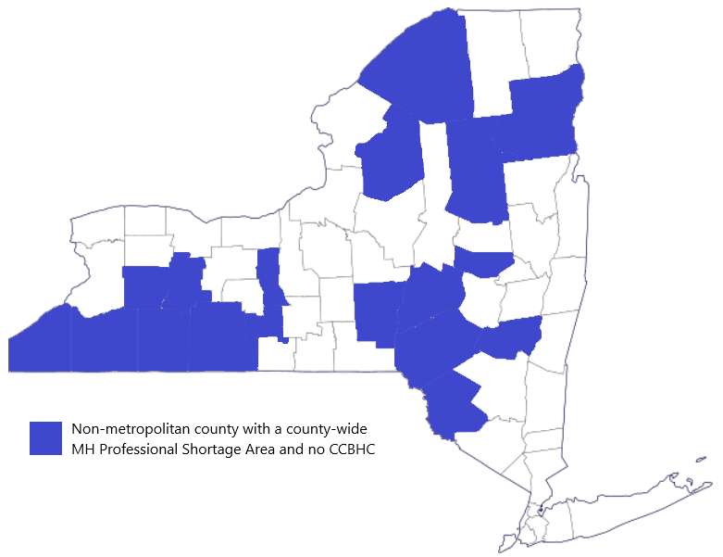
New York has expanded CCBHC access, but gaps persist, especially in rural areas of the state; 19 non-metropolitan counties with a county-wide MHPSA lack any CCBHC. To address these holes in CCBHC access, The Council proposes the expansion of rural CCBHCs based on an any-capable-provider standard rather than a procured program expansion as has been done heretofore. If a provider in a rural part of the state is capable of meeting the higher CCBHC standard, they should be designated a CCBHC without having to await a procurement process that artificially inhibits program expansion and access.
Figure 2: There are 19 non-metropolitan counties in NY with a county-wide MH Professional Shortage Area and No CCBHC

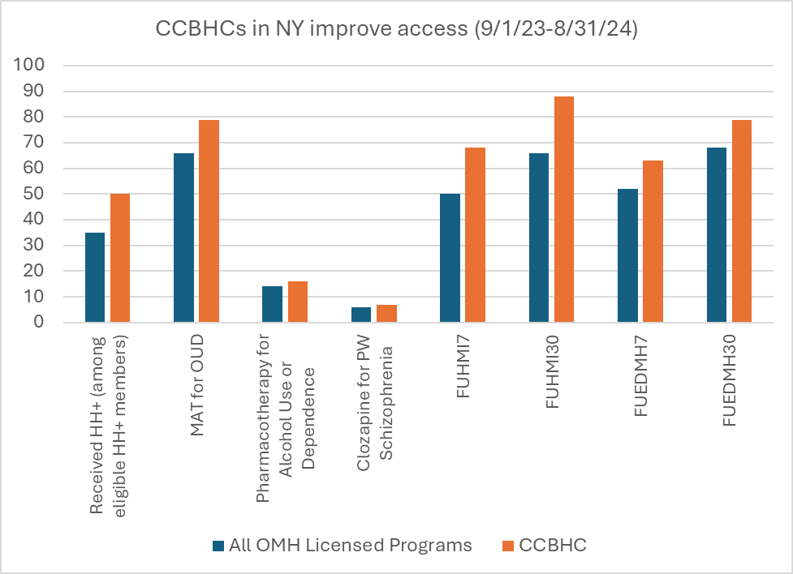
Key Performance Indicators
Figure 3: CCBHCs are demonstrating better access outcomes than other parts of the delivery system.
CCBHCs are required to monitor and report a consistent set of performance indicators, including:
- Time to Services (I-SERV)
- Depression Remission at Six Months (DEP-REM-6)
- Preventive Care and Screening: Unhealthy Alcohol Use: Screening and Brief Counseling (ASC)
- Screening for Social Drivers of Health (SDOH)
- Screening for Clinical Depression and Follow-Up Plan (CDF-AD and CDF-CH)
- Patient Experience of Care Survey (PEC) SAMHSA NA No NA R
- Youth/Family Experience of Care Survey (YFEC)
- Antidepressant Medication Management (AMM-AD)
- Use of Pharmacotherapy for Opioid Use Disorder (OUD-AD)
- Adherence to Antipsychotic Medications for Individuals with Schizophrenia (SAA-AD)
- Plan All-Cause Readmissions Rate (PCR-AD)
- Follow-Up Care for Children Prescribed Attention-Deficit Hyperactivity Disorder (ADHD) Medication (ADD-CH)
- Hemoglobin A1c Control for Patients with Diabetes (HBD-AD)
- Initiation and Engagement of Alcohol and Other Drug Dependence Treatment (IET-AD)
- Follow-Up After Hospitalization for Mental Illness (FUH-CH and FUH-AD)
- Follow-Up After Emergency Department Visit for Mental Illness (FUM-AD and FUM-CH)
- Follow-Up After Emergency Department Visit for Alcohol and Other Drug Dependence (FUA-AD and FUA-CH)

Sustainability
CCBHCs are sustained through a Prospective Payment System rate, which accounts for the higher standard of care CCBHCs provide. CCBHCs generate sufficient savings in emergency and inpatient utilization that they are cost neutral with respect to state Medicaid spending.

Proposal
$3 million in year one, $6 million in year two, $9 million in year three, $12 million in year four, $15 million in year five will enable the establishment of five new CCBHCs in rural counties that do not currently have CCBHC services.

Rural behavioral health data exchange fund

CMS Focus Area: Improve access to coordinated care

Behavioral health providers in New York state have been systematically excluded from some of the major programs designed to improve the technology infrastructure of the healthcare delivery system. New York made a massive $2.7 billion investment to build healthcare information technology capacity, Healthcare Efficiency and Affordability Law for New Yorkers Capital Grant Program (HEAL NY), but behavioral health providers were only invited to apply for 1.4% of the funding. Similar exclusions during DSRIP (only 2.5% of PPS funds were allocated to behavioral health providers) and the VBP QIP program have left safety next behavioral health providers with significant technology capability lapses; the $60 million Behavioral Health Care Collaborative funding barely shows up in New York’s healthcare transformation support budget. These infrastructure gaps impede care coordination, inhibit care quality, and prevent some behavioral health providers from engaging in alternative payment models (APM), including value-based payments (VBP).
Figure 4: HEAL NY funding systematically excluded behavioral health providers
To address this systematic shortchanging of community behavioral health providers and the negative impacts on access and quality that result, The Council proposes the development of a rural behavioral health data exchange fund. This fund would support rural behavioral health providers to connect to the Statewide Health Information Network New York (SHIN-NY), develop data sharing arrangements and workflows with other rural providers, develop data warehouses, improve and enhance their electronic health records, build data sharing tools to share referrals efficiently, enhance cybersecurity measures, and access training and technical assistance to maximize the value of the data providers are sharing for their clients’ access and outcomes.
Figure 5: BH providers in New York received less than one percent of healthcare transformation resources.

Key Performance Indicators
The rural behavioral health data exchange fund will enable providers to follow up more consistently following a hospitalization, and therefore generate improvements in key behavioral health-related HEDIS metrics, including:
- Follow-Up Care for Children Prescribed ADHD Medication (ADD-E)
- Follow-Up After Emergency Department Visit for Substance Use Disorder (FUA)
- Follow-Up After Hospitalization for Mental Illness (FUH)
- Follow-Up After High-Intensity Care for Substance Use Disorder (FUI)
- Follow-Up After Emergency Department Visit for Mental Illness (FUM)
- Initiation and Engagement of Substance Use Disorder Treatment (IET)
- Adherence to Antipsychotic Medications for Individuals with Schizophrenia (SAA)

Sustainability
The rural behavioral health data exchange fund will create capacity within the delivery system that will be supported on an ongoing basis by provider billing and administrative overhead. In addition, improved data exchange capabilities will enable providers to engage in APMs that will support the maintenance of the infrastructure developed through this fund.

Proposal
$6 million per year for five years will enable 20 rural behavioral health providers to improve their data sharing capabilities

Rural behavioral health workforce incentive fund

CMS Focus Area: Improve access to qualified care providers
The behavioral health workforce crisis is particularly acute in rural areas, which are more likely to lack behavioral health providers, and in which people who access care frequently can do so only from primary care providers. Positions that require credentials or licensure are especially difficult to recruit and retain. To address these workforce challenges, and the access problems they create, The Council proposes the development of a rural behavioral health workforce incentive fund. This fund would be used to support rural behavioral health providers’ development and adoption of innovative solutions to address the rural behavioral health workforce crisis, including procurement and implementation of workforce extending software and applications; development of Artificial Intelligence (AI) governance, policies, and procedures; cover supervision time; support relationship development between the community behavioral health and education sectors; and provide signing bonuses for recruits to rural behavioral health providers.

Key Performance Indicators
Improved staffing of community behavioral health providers will have an impact on key HEDIS measures, including:
- Follow-Up Care for Children Prescribed ADHD Medication (ADD-E)
- Follow-Up After Emergency Department Visit for Substance Use Disorder (FUA)
- Follow-Up After Hospitalization for Mental Illness (FUH)
- Follow-Up After High-Intensity Care for Substance Use Disorder (FUI)
- Follow-Up After Emergency Department Visit for Mental Illness (FUM)
- Initiation and Engagement of Substance Use Disorder Treatment (IET)
- Adherence to Antipsychotic Medications for Individuals with Schizophrenia (SAA)

Sustainability
Investments in workforce will help rural behavioral health providers stabilize their financial situations. When they are able to reduce spending needed to recruit, replace, and retrain staff as frequently, they will be able to invest in improving operating environments and compensation. These investments will be sustained eventually through billing for services being provided by the more experienced and more efficient staff.

Proposal
$4 million per year for five years

Rural behavioral health quality improvement fund

CMS Focus Area: Improve access to quality care
Community behavioral health providers operate heavily regulated services with tight budgets and significant staff turnover. This operating environment makes it challenging to engage in quality improvement projects that would improve care delivery and coordination, expand access, and enhance operational efficiency, supporting the sustainable operation of rural behavioral health services. The impact of these improvements can be long-term as improved workflows and optimized scheduling lead to greater capacity, shorter waiting lists, improved patient flow-through and staff who are consistently operating at the top of their license.
The Council proposes the establishment of a rural behavioral health quality improvement fund to support learning collaboratives of rural providers emphasizing care team redesign to reduce no-shows, decrease provider burnout by promoting timely note closure, and enable staff to work at the top of their license. This approach also improves efficiency and capacity by optimizing provider schedules. By focusing on cycle times, missed opportunities for patient follow-up, and direct patient engagement, this model creates more effective care teams that increase access and strengthen prevention and chronic disease management in rural communities.

Key Performance Indicators
The rural behavioral health quality improvement fund will have an impact on key HEDIS measures, including:
- Follow-Up Care for Children Prescribed ADHD Medication (ADD-E)
- Follow-Up After Emergency Department Visit for Substance Use Disorder (FUA)
- Follow-Up After Hospitalization for Mental Illness (FUH)
- Follow-Up After High-Intensity Care for Substance Use Disorder (FUI)
- Follow-Up After Emergency Department Visit for Mental Illness (FUM)
- Initiation and Engagement of Substance Use Disorder Treatment (IET)
- Adherence to Antipsychotic Medications for Individuals with Schizophrenia (SAA)

Sustainability
Because the rural behavioral health quality improvement fund will, in addition to focusing on clinical quality, focus on operational and efficiency improvements, the long-term impact of the fund will be providers operating more efficiently. This will enable the sustainability of rural behavioral health providers through increased and improved billing.

Hubs for medication for opioid use disorder and long-acting injectable antipsychotics

CMS Focus Area: Improve access to pharmacologic care
New York is one of eight states in which drug overdose deaths are higher in rural counties than in urban ones. Medications for opioid use disorders (MOUD), including methadone, buprenorphine, and naltrexone, are evidence-based treatments for opioid use disorder (OUD). They reduce all-cause mortality, infectious disease risk, crime, and relapse, while increasing long-term recovery. MOUD is essential for breaking the physical symptoms of addiction. When offered in alignment with best practices, MOUD is a critical component of a comprehensive continuum of care that includes talk therapy, peer counseling, and other recovery supports. Access to MOUD can be inhibited in rural areas by lack of volume needed to support the necessary expertise and infrastructure.
In addition, long-acting injectable antipsychotics (LAIs) offer unique benefits that can be important facilitators of recovery for New Yorkers with schizophrenia, bipolar disorder, and other serious mental illnesses (SMI). LAIs reduce mortality risk, improve adherence, increase clinical stability, enhance quality of life, decrease relapse and rehospitalization risk, ease clinician monitoring, maintain drug level stability, and promote long-term savings. As with MOUD, LAIs are frequently inaccessible in rural areas because the costs of providing them are so high that providers require significant volume to offer LAIs sustainably; rural areas make the necessary volume difficult to generate. In addition to the medical capabilities required to oversee the injection, the upfront costs of the injections impede access.
To address the challenges in accessing MOUD and LAI in rural areas, The Council proposes the development of MOUD/LAI hubs. This innovative model will bring together behavioral health providers, primary care providers, pharmacies, and outreach agencies, who will leverage technology and share resources to ensure access to these vital behavioral health treatments.

Key Performance Indicators
The MOUD and LAI hubs will generate improvements in key behavioral health-related HEDIS metrics, including:
- Initiation and Engagement of Substance Use Disorder Treatment (IET)
- Adherence to Antipsychotic Medications for Individuals with Schizophrenia (SAA)
- Diabetes Screening for People with Schizophrenia or Bipolar Disorder Who Are Using Antipsychotic Medications (SSD)
- Pharmacotherapy for Opioid Use Disorder (POD)

Sustainability
The MOUD and LAI hubs will be supported through billing for the services it provides and through engaging in APMs.

Proposal
$6 million per year for five years will enable the establishment of six MOUD/LAI hubs

Strengthen Telehealth Capacity and Develop Regional eConsult Partnerships
CMS Focus Area: Access to integrated primary and behavioral healthcare
We recommend creating a training and technical assistance program to promote telehealth and eConsult optimization, specifically, to promote optimal use of audio-visual platforms and close collaboration among regional partners: behavioral health providers, health centers, and hospitals.
While many community-based mental health and substance use disorder provider organizations and community health centers rapidly built out telehealth infrastructure in the early days of COVID-19, the hurried nature of that development means that few have had the time to robustly learn to use telehealth platforms to their full ability. Due to the unique challenges of broadband availability and patient preference, many rural providers rely on audio-only telehealth visits. Targeted technical support could help these provider organizations to develop robust audiovisual telehealth workflows, with the goal of improving scheduling and expanding access to primary care and chronic disease management services.
Expanding the use of eConsults through improved IT platforms, workflow optimization, and formalizing partnerships between behavioral health organizations, regional rural health centers, and hospitals would increase local referrals and ensure timely access to specialty expertise for rural patients who often face long travel times and limited access to care. Funding would allow providers to bring in expert consultants to support providers in optimizing their workflows. Proposals including multi-sector collaboration such as this in which our members could work closely with rural community health centers represented by CHCANYS, hospital associations including Iroquois, and others should be favored to ensure strong community partnerships.

Key Performance Indicators
The Mobile Behavioral Health clinics will generate improvements in key primary care behavioral health integration-related HEDIS metrics, including:
- Depression Screening and Follow-Up for Adolescents and Adults (DSF-E)
- Utilization of PHQ-9 to Monitor Depression Symptoms for Adolescents and Adults (DMS-E)
- Depression Remission or Response for Adolescents and Adults (DRR–E)
- Unhealthy Alcohol Use Screening and Follow-Up (ASF-E)
- Postpartum Depression Screening and Follow-up (PDS-E)

Sustainability
The eConsult and telehealth capacity developed by this initiative will be sustained by billing for the services provided. In addition, the collaborations developed through this initiative could lead to value-based payment contracting.

Proposal
$1 million per year for five years

Mobile behavioral health clinics

CMS Focus Area: Improve access to on-site care
Access to behavioral healthcare in rural areas is complicated by the distances people must travel to get care. Telehealth has been invaluable for addressing this challenge, but there are populations for whom telehealth access is inadequate. Many New Yorkers struggle with developing a therapeutic alliance with their therapist if they are speaking with them online and experience better outcomes when they meet in-person. This is especially (although not only) true at both ends of the lifecycle for older New Yorkers and kids, who are frequently isolated and in need of significant behavioral healthcare. In addition, many New Yorkers lack sufficient broadband access to take advantage of telehealth services.
In order to ensure access to in-person behavioral health treatment for rural New Yorkers, The Council proposes the procurement of 10 mobile behavioral health clinics that will enable behavioral health providers to go to where their clients are, whether they are an isolated senior, a child in a school with no on-site behavioral health clinic, a person who is homeless, a person who lacks sufficient broadband to take advantage of telehealth, or any other rural resident who lacks easy access to high quality behavioral healthcare for transportation reasons.

Key Performance Indicators
The Mobile Behavioral Health clinics will generate improvements in key behavioral health-related HEDIS metrics, including:
- Follow-Up Care for Children Prescribed ADHD Medication (ADD-E)
- Follow-Up After Emergency Department Visit for Substance Use Disorder (FUA)
- Follow-Up After Hospitalization for Mental Illness (FUH)
- Follow-Up After High-Intensity Care for Substance Use Disorder (FUI)
- Follow-Up After Emergency Department Visit for Mental Illness (FUM)
- Initiation and Engagement of Substance Use Disorder Treatment (IET)
- Adherence to Antipsychotic Medications for Individuals with Schizophrenia (SAA)

Sustainability
The mobile behavioral health clinics will be sustained by billing for the services provided. New York State has established a Licensed Behavioral Health Practitioner (LBHP) benefit that makes it financially viable for community behavioral health providers to provide the type of on-site visits that will sustain the mobile behavioral health clinics.

Proposal
$1 million

Summary table
As is indicated in the table below, the proposals put forth by The Council are closely aligned with the federal requirements and permissible uses for the Rural Health Transformation Program
 | Rural CCBHC | BH data exchange | BH workforce | Quality Improvement | LAI/MOUD Hubs | eConsult | Mobile BH
Requirements
Improved access to hospitals and other providers | ✔ | ✔ | ✔ | ✔ | ✔ | ✔ | ✔
Improves health outcomes of rural residents | ✔ | ✔ | ✔ | ✔ | ✔ | ✔ | ✔
Prioritizes the use of new technology that emphasizes prevention and chronic  disease management | ✔ | ✔ |  | ✔ | ✔ | ✔ | ✔
Initiate or strengthen regional strategic partnerships amongst rural providers to promote measurable quality improvements and financial stability | ✔ | ✔ | ✔ |  | ✔ | ✔
Enhance economic opportunity for the supply of health clinicians through recruiting and training | ✔ |  | ✔ | ✔ | ✔ | ✔
Prioritize data and technology driven patient solutions | ✔ | ✔ | ✔ | ✔ | ✔ | ✔ | ✔
Outlines strategies to manage long-term financial solvency and operating models of rural hospitals | ✔ | ✔ | ✔ | ✔
Identifies specific causes driving the accelerating rate of stand-alone rural hospitals becoming at risk of closure, conversion, or service reduction | ✔ | ✔ | ✔ | ✔
Uses
Promoting evidence-based, measurable interventions to improve prevention and chronic disease management. Improves health outcomes of rural residents | ✔ | ✔ | ✔ | ✔ | ✔ | ✔ | ✔
Providing payments to health care providers for the provision of health care items or services, as specified by the Administrator | ✔ |  |  |  | ✔
Promoting consumer-facing, technology-driven solutions for the prevention and management of chronic diseases | ✔ | ✔ | ✔ | ✔ | ✔ | ✔ | ✔
Providing training and technical assistance for the development and adoption of technology-enabled solutions that improve care delivery in rural hospitals, including remote monitoring, robotics, artificial intelligence, and other advanced technologies |  | ✔ | ✔ | ✔ | ✔ | ✔
Recruiting and retaining clinical workforce talent to rural areas, with commitments to serve rural communities for a minimum of 5 years | ✔ |  | ✔ | ✔ | ✔ |  | ✔
Providing technical assistance, software, and hardware for significant information technology advances designed to improve efficiency, enhance cybersecurity capability development, and improve patient health outcomes |  | ✔ |  | ✔ | ✔ | ✔
Assisting rural communities to right size their health care delivery systems by identifying needed preventative, ambulatory, pre-hospital, emergency, acute inpatient care, outpatient care, and post-acute care service lines. | ✔ | ✔ | ✔ | ✔ | ✔ | ✔ | ✔
Supporting access to opioid use disorder treatment services (as defined in section 1861(jjj)(1)), other substance use disorder treatment services, and mental health services | ✔ | ✔ | ✔ | ✔ | ✔ | ✔ | ✔
Developing projects that support innovative models of care that include value-based care arrangements and alternative payment models, as appropriate | ✔ | ✔ |  | ✔ | ✔ | ✔ | ✔
Additional uses designed to promote sustainable access to high quality rural health care services, as determined by the Administrator | ✔ | ✔ | ✔ | ✔ | ✔ | ✔ | ✔

U. S. Department of Health and Human Services, Health Resources and Services Administration, Rural Health Information Hub, (2025). Health Professional Shortage Areas: Mental Health, by County, July 2025 - New York Nonmetropolitan via https://www.ruralhealthinfo.org/charts/7?state=NY
Office of the State Comptroller (2025). The Doctor is… Out: Shortages of Health professionals in Rural Areas https://www.osc.ny.gov/files/reports/pdf/rural-health-shortages.pdf
New York State Department of Health, Office of Mental Health (2025), Spotlight on Rural Mental Health. https://omh.ny.gov/omhweb/cultural_competence/spotlight-on-rural.pdf
NY OMH: Initial Results from DY1 and DY2 Show Potential for Improving Outcomes, February 17, 2022 at National Council for Mental Wellbeing meeting, The Certified Community Behavioral Health Clinic (CCBHC) Model: A Learning Collaborative for State Government Officials.
Dickerson C, Rosenzweig C, Rubin J, An Analysis of the Financial Impact of New York State’s Certified Community Behavioral Health Clinic (CCBHC) Demonstration Program Prepared for New York State Council for Community Behavioral Healthcare by Health Management Associates and Edrington Health Consulting, December 2022.
https://omh.ny.gov/omhweb/tableau/vital-signs.html
NYSCCBH recognizes that the appropriate comparison group is all OMH and OASAS licensed providers, but data regarding these performance indicators for OASAS programs are not publicly available.
Source: https://www.health.ny.gov/health_care/managed_care/appextension/ docs/f-shrp_annual_report_oct_sept_2012.pdf
Source: NYS Department of Health. VBP QIP Funding and Pairing Tables, September 2018. https://www.omh.ny.gov/omhweb/bho/bh-vbp.html and https://www.health.ny.gov/health_care/medicaid/redesign/dsrip/.
https://bhw.hrsa.gov/sites/default/files/bureau-health-workforce/state-of-the-behavioral-health-workforce-report-2024.pdf
https://www.cdc.gov/nchs/products/databriefs/db440.htm
National Academies of Sciences, Engineering, and Medicine; Health and Medicine Division; Board on Health Sciences Policy; Committee on Medication-Assisted Treatment for Opioid Use Disorder; Mancher M, Leshner AI, editors. Medications for Opioid Use Disorder Save Lives. Washington (DC): National Academies Press (US); 2019 Mar 30. 2, The Effectiveness of Medication-Based Treatment for Opioid Use Disorder. Available from: https://www.ncbi.nlm.nih.gov/books/NBK541393/
Lin D, Thompson-Leduc P, Ghelerter I, Nguyen H, Lafeuille MH, Benson C, Mavros P, Lefebvre P. Real-World Evidence of the Clinical and Economic Impact of Long-Acting Injectable Versus Oral Antipsychotics Among Patients with Schizophrenia in the United States: A Systematic Review and Meta-Analysis. CNS Drugs. 2021 May;35(5):469-481. doi: 10.1007/s40263-021-00815-y. Epub 2021 Apr 28. Erratum in: CNS Drugs. 2021 Aug;35(8):923. doi: 10.1007/s40263-021-00850-9. PMID: 33909272; PMCID: PMC8144083.

