UHF HR1 Impact
Webinar Notes
6/18/26

Amir Bassiri comments
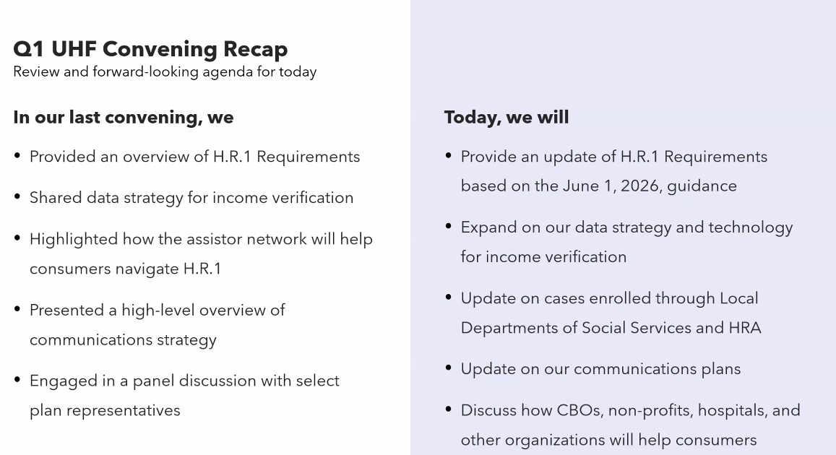
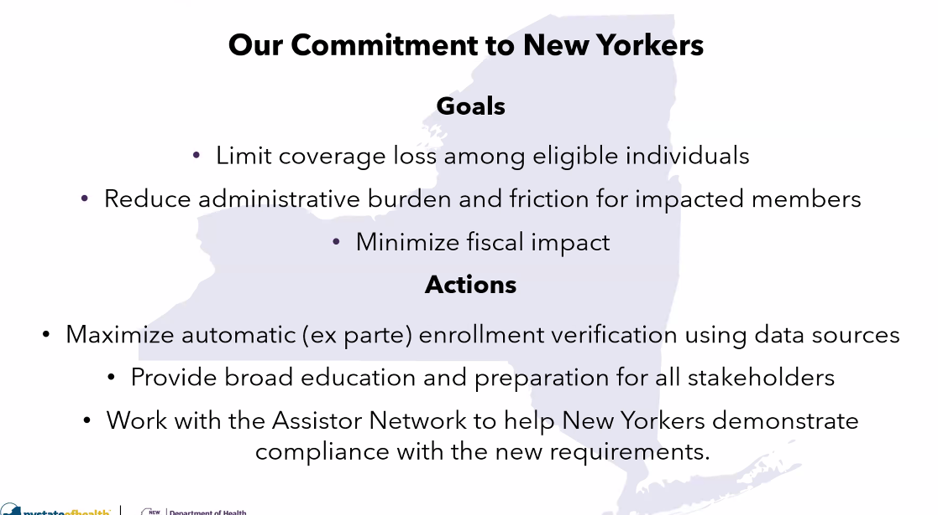
Intend to double down on assistor network.
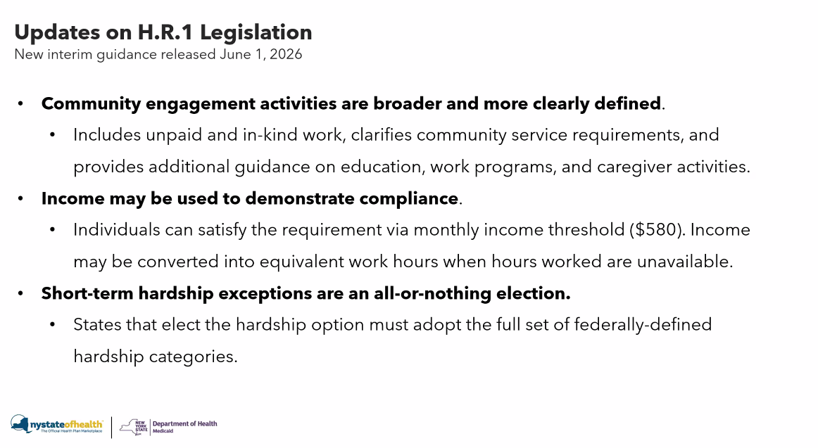
This is NYS interpretation of these details. Six buckets for things that are helpful to highlight for new Yorkers.
These are things NY has alluded to in the last meeting – they have been clarified and confirmed.
Big change- had assumed could choose one or many of available short term exemption options. We are not able to select one or two, its all or nothing approach. Would have to adopt all short term hardship exemptions. The administrative complexities are difficult. NY will be applying for all exemptions – but still need additional info from CMS.
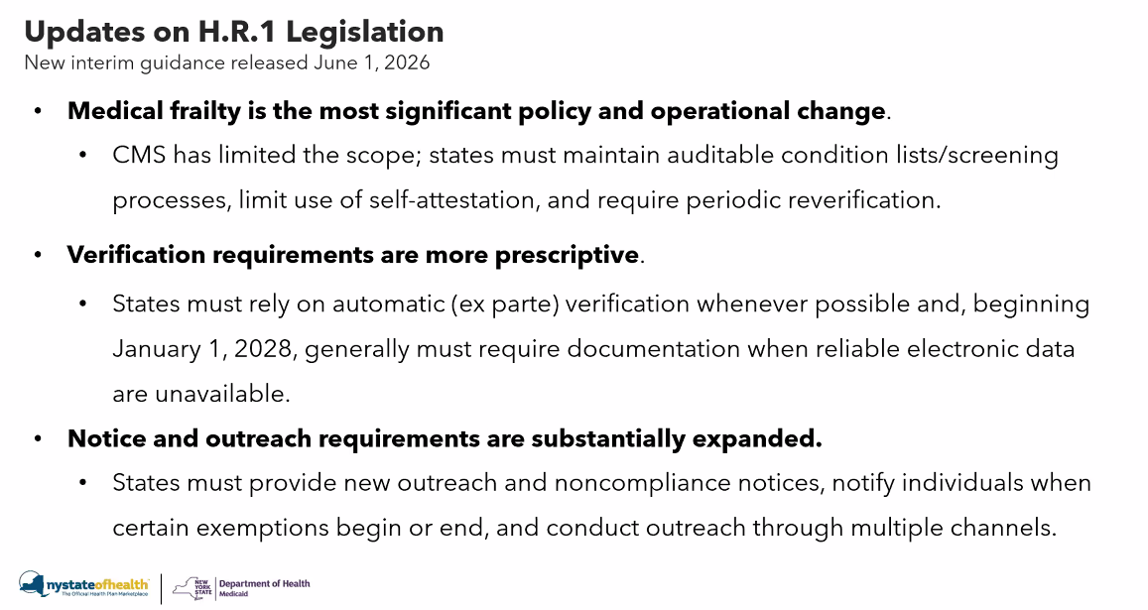
Medical frailty is largest change from initial legislation.
All states are grappling with these changes to medical frailty. The approach NY is taking is compliant (according to CMS).
Verification requirements are a little ‘wonky’. Needing to rely on automatic verification, which is good. In 2028 require documentation alongside automatic verification.

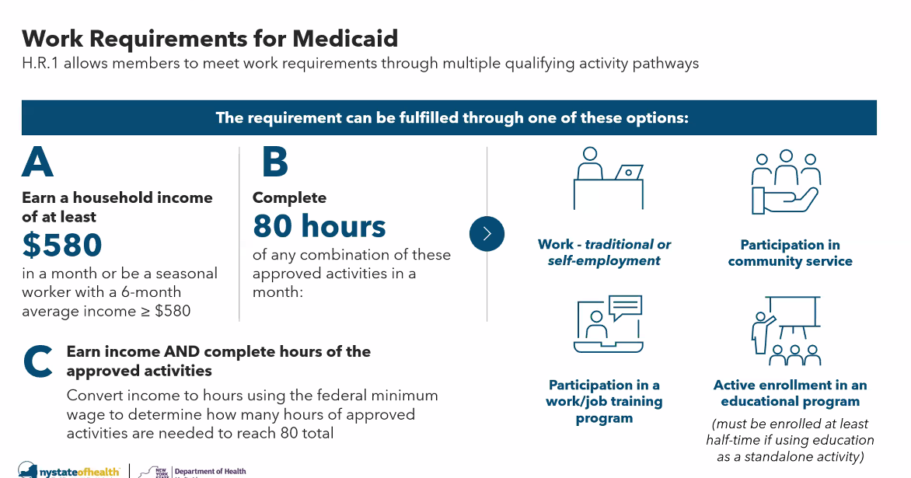
You can extrapolate – if you have $480 – you can determine that would have 66 hours and you need 14 more hours to be compliant. Someone could do 14 hours of community service to be compliant.
You can use in-kind hours to help meet the exemptions. This can be a combo of community service, education, and work to meet the 80 hours.
This is the most important aspect of our ability to keep Nyers covered. This will be the most impactful exemption. If any one person in the household has done 80 hours – the whole family is qualified in the household.
We can use both to convert and meet the requirement – most important exemption with implementation and will continue to be.
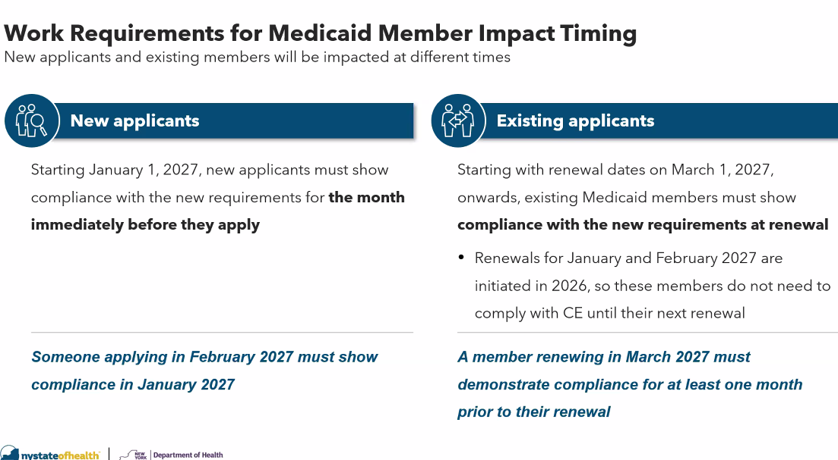
Jan/Feb renewals not subject to community engagement requirements.
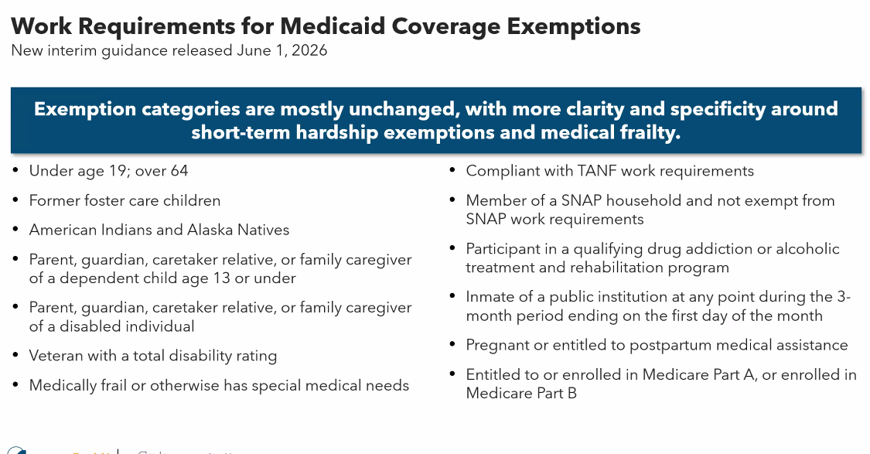
We think $580 is the biggest group. Large percentage of individuals with child under the age of 13 will qualify for exemption too. Largely unchanged from what the law states.
At least one person in the household is required to meet the requirement ($580) if there are more than one family member in the household on Medicaid.
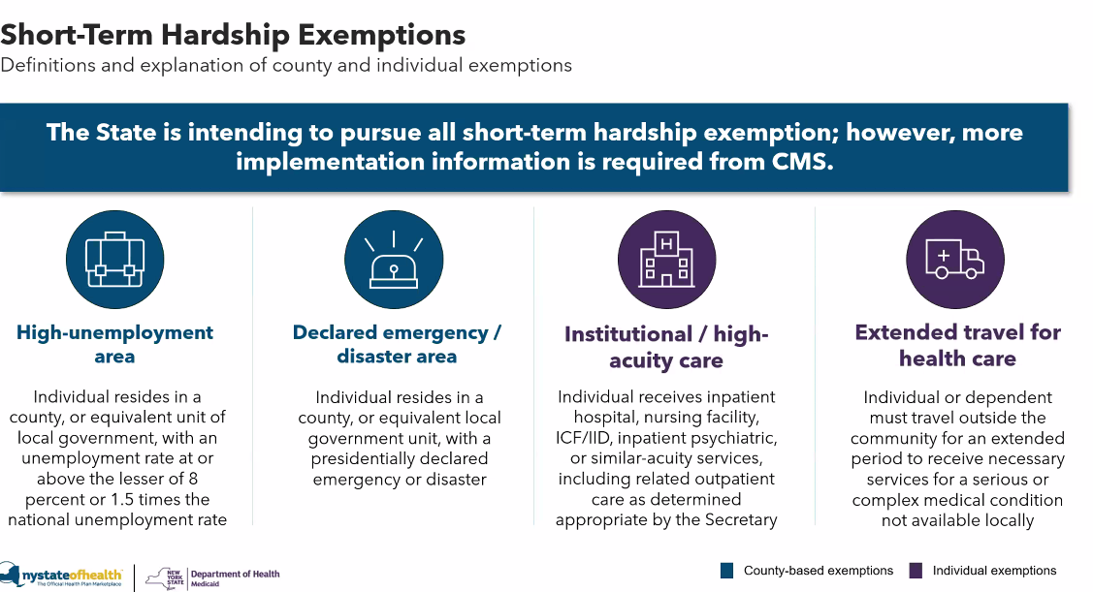
NY thought we could pick and choose of the short term hardships. IFR clarified it would have to be all four. NY is pursuing all of them. It does bring additional complication.
First bullet – some big counties potentially meet this requirement. NY will need to ask CMS for approval to use this exemption by documenting to them that we’ve met the parameters to quailify for the exemption.
Second bullet – this changes frequently, but also requires CMS approval.
Third bullet –
Fourth bullet – NY is really trying to figure out how to operationalize. Another complication NY wasn’t expecting, we need to inform people when these short term exemptions end. We have to think trhough this – we might not know when it would end, and we have to figure out how to operationalize this.
It sounds simple but it’s very complex. Giving notice is the difficulty. Unemployment data is reported elsewhere, not DOH - but we don’t know when those data sources indicate the condition is no longer met. We need to make sure people have the right information at the right time. It is unclear how impactful these exemptions will be.
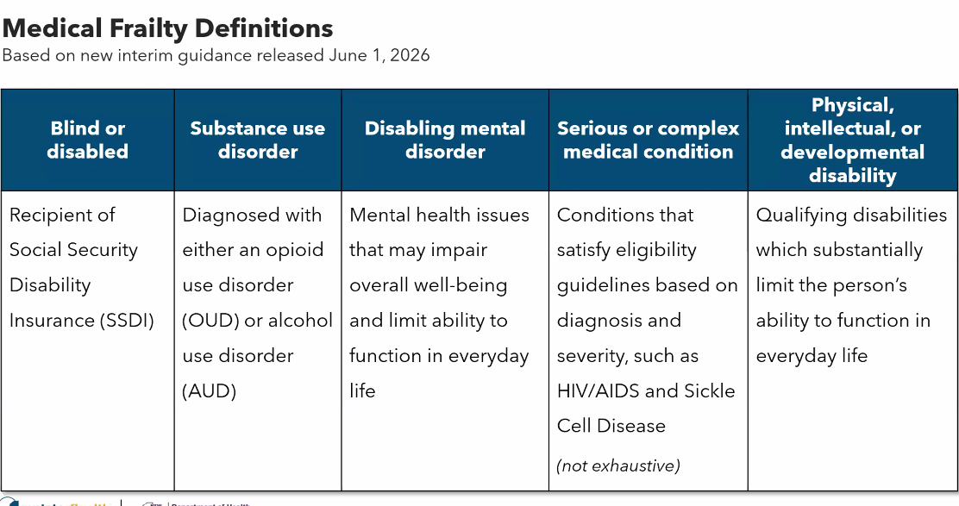
Your disability has to be so severe that you cant meet the community engagement requirements. More restrictive than NY expected.
NY has tried to map out how we can identify individuals through claims data. CMS has pointed to a set of codes to go back to, to show how we’re defining medical frailty. Certain states have been identified as ‘acceptable’ – NY is fairly similar to those.
NY has been talking across states to get details to their approach. Louisiana has been leading the charge to work with other states and CMS to develop underlying methodology and code set. NY is going to align with Louisiana. Very similar to what NY is already working on, working on nuances now.
A lot of talk on medical frailty exemption. 30-40% of the impacted population will qualify. 60% of people will not meet these exemptions, DOH will need programmatic and operational infrastructure to support these other people.
NY needs to rely on screening tools, codes, and limit self-attestation. Need to document whenever it can’t be verified otherwise. Try to use data first. If we can’t it needs to be documented.
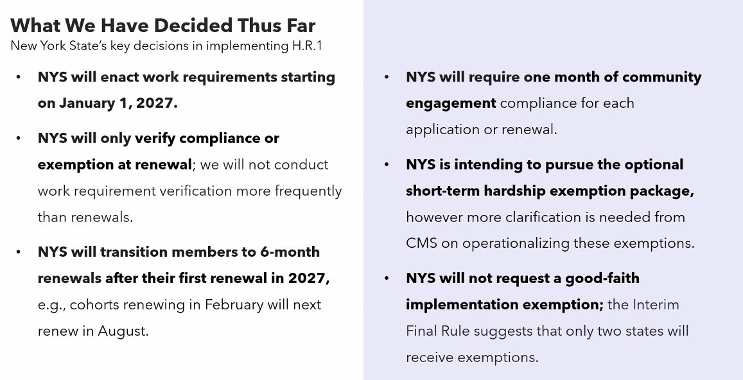
Only verifying compliance or exemption at renewal – not more frequently than the 6-month timeline. Other states are doing monthly.
Law allows for up to three months for community engagement, we selected the least length at one month.
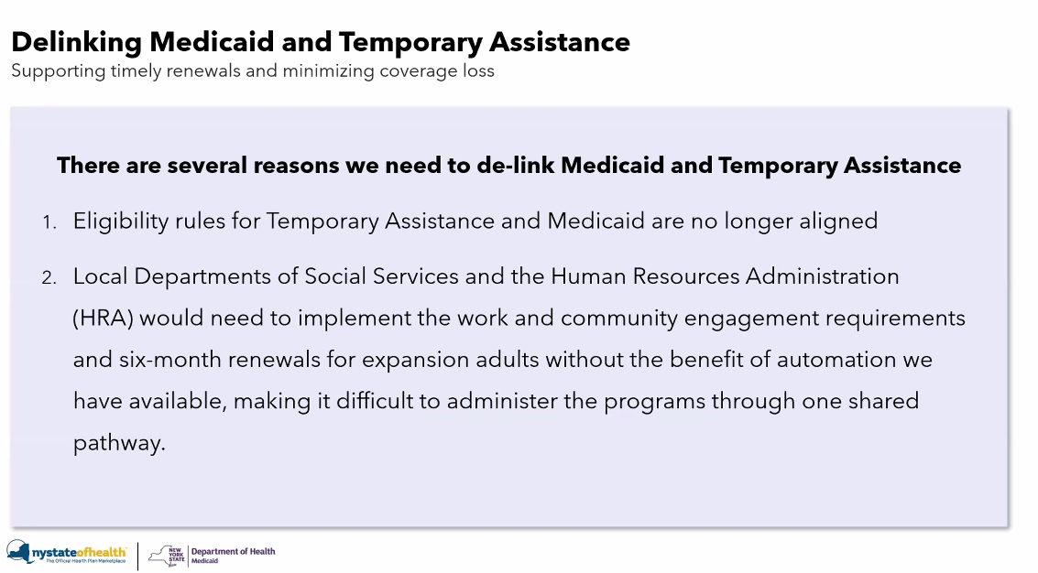

Rules have grown apart over the years with the ACA. We are relying on automation, trying to build in ex parte renewal and new data sources in our modern eleigibily systems that cannot be done in WMS. Local districts to implement 6 month renewals will struggle with staffing issues.
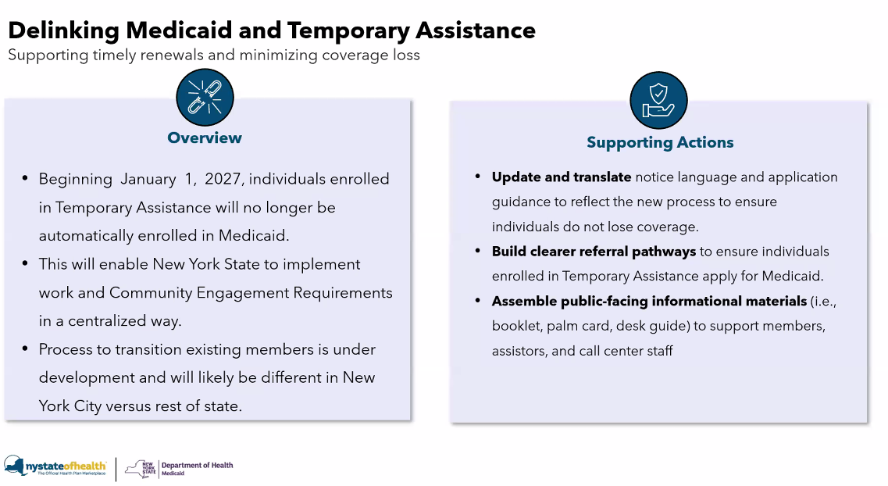
Working with OTDA to operationalize this. Starting in Jan, any new applicant for TA will no longer be enrolled automatically in Medicaid. They will need to specifically apply to get Medicaid.
Individuals will need many channels open to them as possible to ensure maintained coverage.
It’s not only going to be NYSOH, some will enroll in Medicaid eligibility client management system. Some will remain with LDSS, services they need not available other places. Three paths for Medicaid enrollment.
Looking at notice language with OTDA, changing applications, and the tools and pathways people need to know to separately apply for Medicaid.
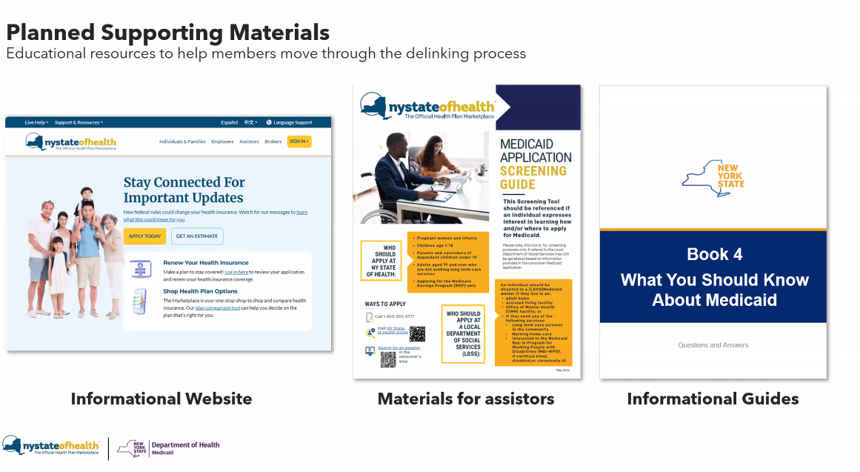
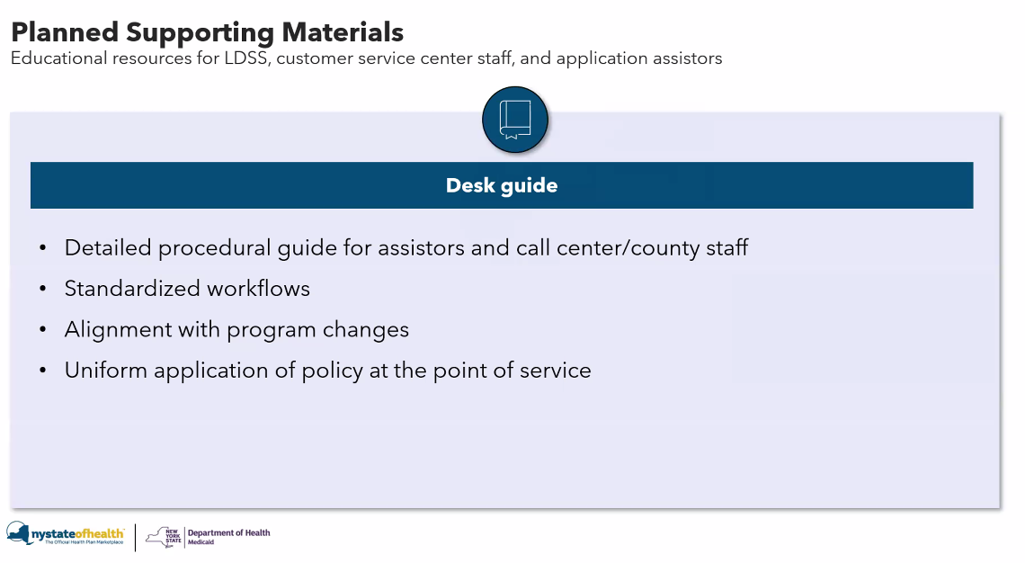
Materials for consumers and for local district staff. Customer service center can help people apply over the phone. Assistor network to receive training. Workflows and changes being worked on. Should assistors be co-located at LDSS when someone applies for TA. OTDA is interested in this idea. DOH to send a survey to LDSS to find out if assistors are already co-located in LDSS.

Would OTDA eligibility workers interested in being trained as assistors?
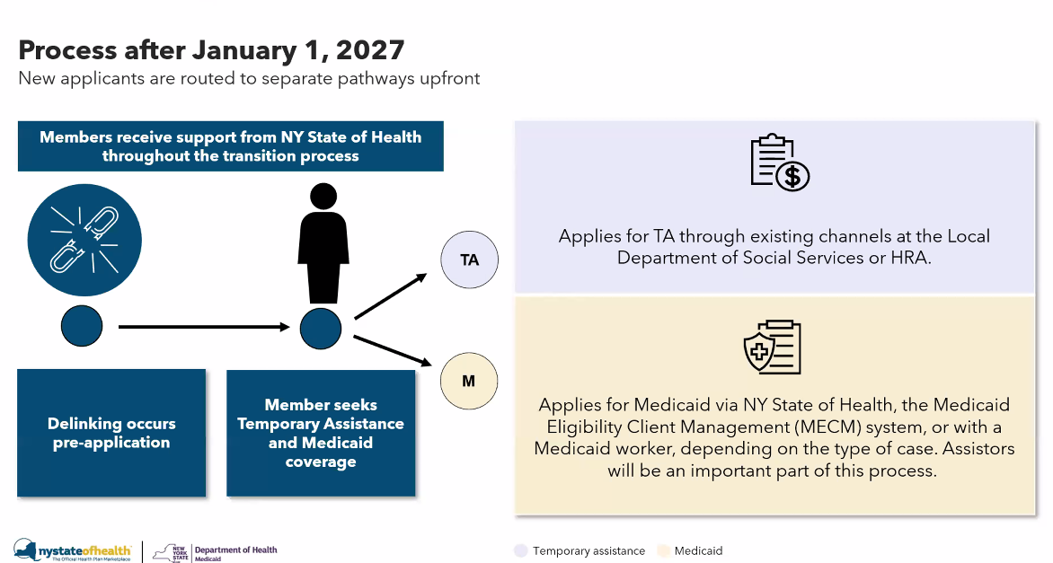
Will need to apply for TA and Medicaid separately starting jan 1 2027.
Are individuals on TA known to NYSOH? Huge number of TA have been on NYSOH but cycled off when TA activated.
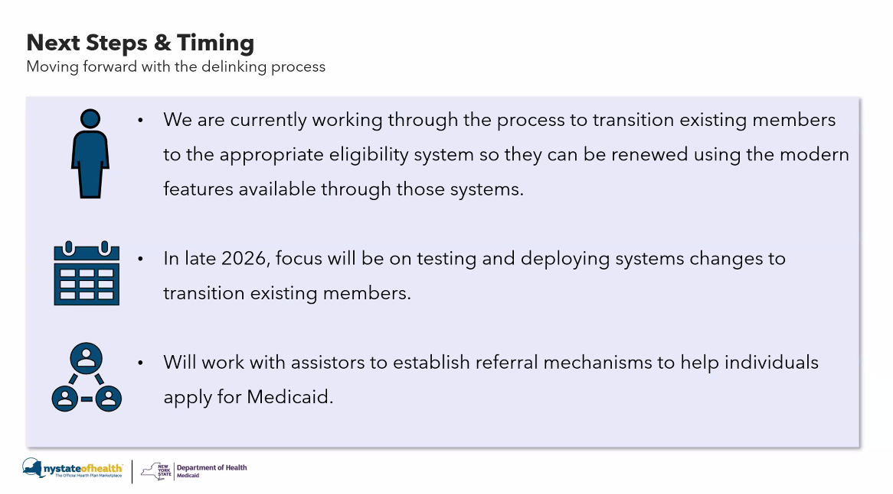
How to transition existing membership. In ROS it will be in two big scoops of people before the renewal. They can renew through NYSOH or MECM – taking advantage of automation.
NYC will be different – still working out details.
Critically important to ensure people are not lost once community engagement requirements are implemented.

Most people will be going through NYSOH – those who need continuity of care to maintain supports will remain through the LDSS.

Danielle Holahan – ED NYSOH
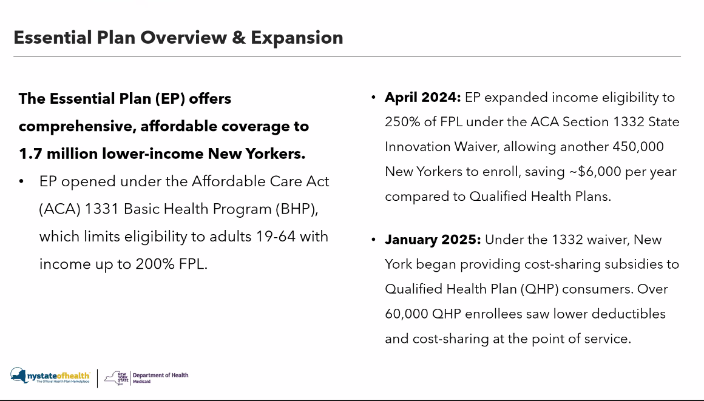
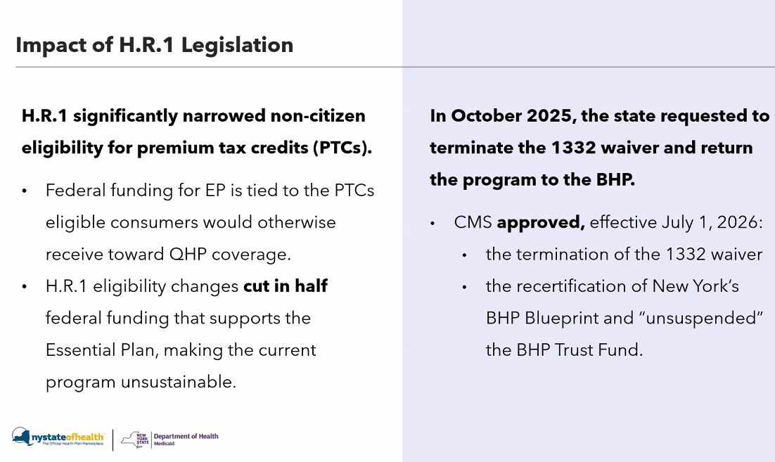
PTCs are how EP is funded. With cuts, it impacted EP funding, cut roughly in half. Unsustainable to operate as structured.
This was approved in March (to return to BHP on July 1), reverting to how the plan looked before the wiaver. Unsuspended BHP trust fund (9 bil) can be leverage to continue to operate the program.
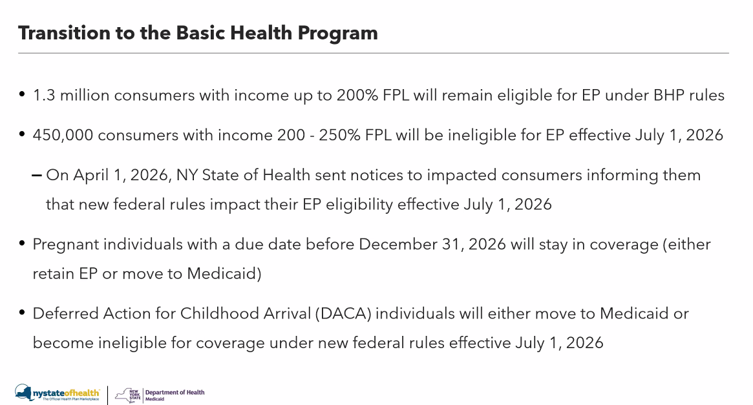
NY is able to protect and preserve coverage for 1.3 million.
Unfortunately, 450k covered under the waiver, effective July 1 their eligibility ends. Starting alerting them Apr 1st.
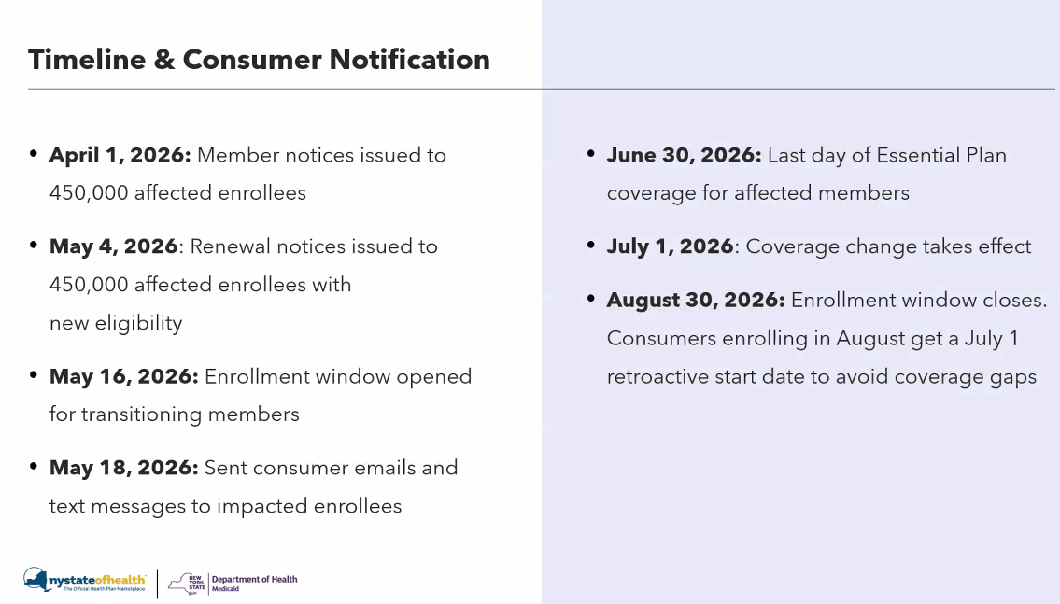
Enrollment assistors have been reaching out. Call center has been very busy. Navigators are also helping with changes.
Coverage will go retro back to July 1 if applied by Aug 30th.
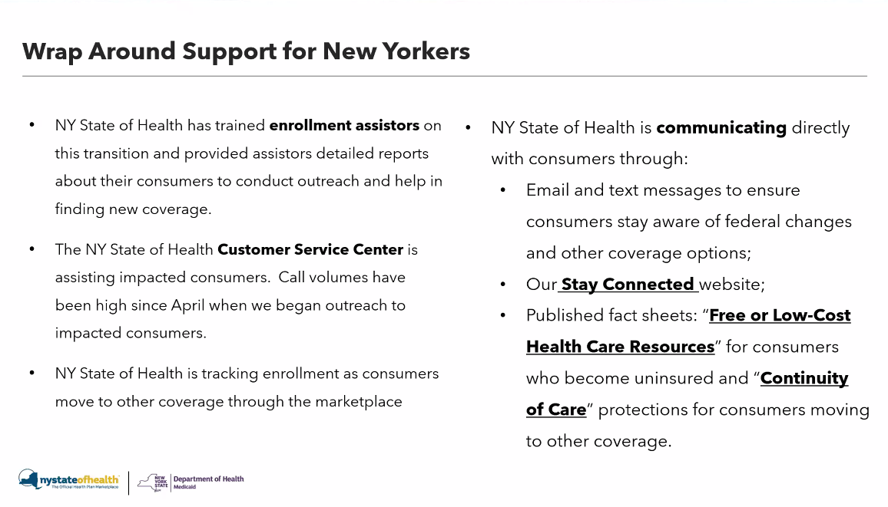
Too early to report numbers being tracked for enrollment. Many consumers are staying at other levels of coverage through the marketplace.
There will be some consumers who become uninsured as a result of this change.
These changes are driven by federal law, nys is doing what it can to ensure the transition is smooth for consumers and to keep folks insured.

Questions: will they continue to allow consumers 200-250% to enroll in EP through the end of the month?
People 200 – 250% are still able to enroll in EP through the end of the month, yes.
Question: will there be an update on undocumented 65 and older on Medicaid?
There are no changes to that program outside it being administered through FFS. People can still enroll if they are eligible.
Question: explain how DOH will implement work requirements for that NYS has exempted from TANF work requirements?
Still looking at that right now, will follow up.
Question: Can you explain how the income of $580 works again?
To demonstrate that they have earned $580 of gross income, which is being treated as an exemption to meet the requirement. That's the first step. The second is to do the 80 hours or show that you worked or had community engagement or educational activities of 80 hours. And then the third is a combination of income and hours. So it's more flexible than it had originally been envisioned. And then on top, so that's just for an individual. Those are the three ways they would be able to demonstrate. For households, it's also favorable from our perspective in that only one individual within the household has to meet the requirement. That may be the only person subject to the requirement. Um, you know, if you have kids or or dependents that are exempt. But if you had one working parent and one non-working parent in the same household and the working parent had the $580 of gross monthly income, both parents would be treated as exempt even though only one is meeting that requirement.
Question: nuance between the work requirements, 6-month renewal – and interplay with those who have children under 13.
We will want to respond to this in writing to be clear, there are parents in the adult group, we have some other eligibility rules and logic that will ensure parents remained covered.
Question: Can two people’s income qualify for the $580 requirement?
One person meeting the requirement is what exempts the household. Cannot combine the exemption among multiple members of the household – like work hours or income or community service. One person must meet the requirements, but that qualifies the entire household.
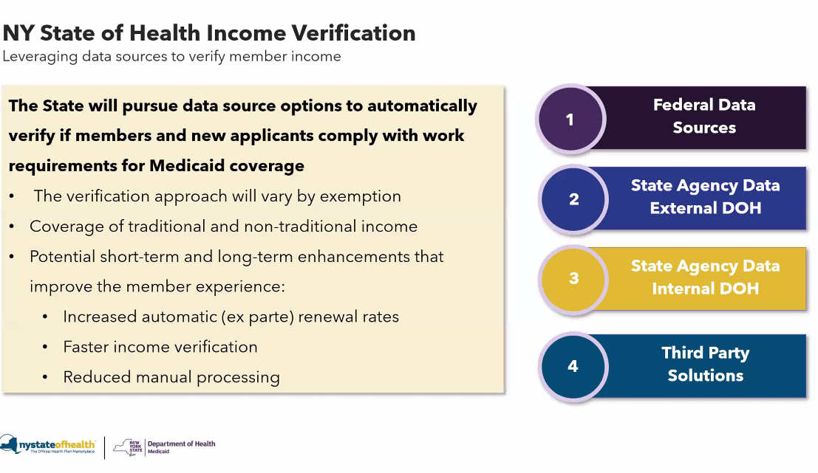
Roughly 2 million people subject to work requirements. There are various exemptions we’ve talked about in detail, but the majority of folks will have to verify their work. How is NYS approaching this? Even if we had inifite resource, we could not do manual verification. Shoring up data sources we currently have (IRS), state data sources (dept of tax and finance), connection with OTDA as well.
Third party data source we are adding for income. Purpose of work is to increase the number of folks verified automatically to reduce the need for manual processing.
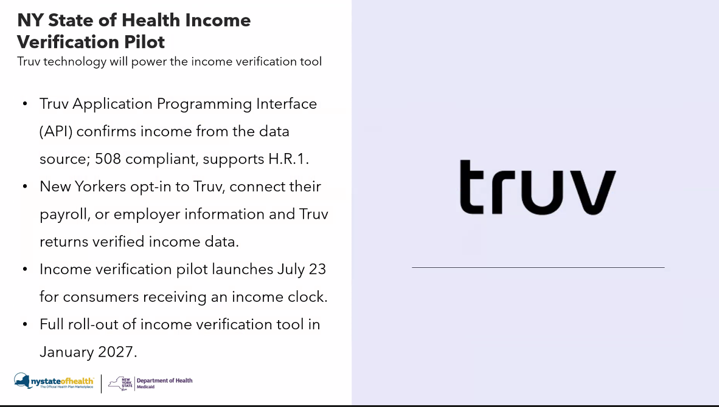
NYS focused on looking at who are current data sources don’t capture. Self-employed, gig economy workers. Trouble verifying income in those jobs. NYS decided to go with TRUV – will be explained how the tool works. Consent-based verification tool.
Thanks to the philanthropic support – as we enter phase where folks have to verify information and use a new data source unfamiliar with – focused on consumer trust. We are partnering with Code for America to pilot at the end of this summer to test how users are working with the new tool.
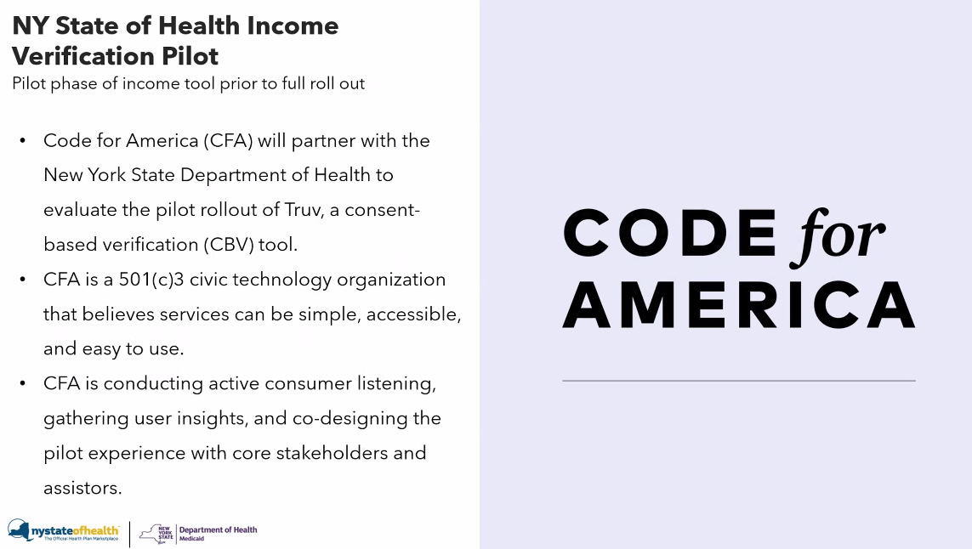
What is consent based verification?
Income verification is highest friction point in eligibility. Alternative to manual documents – share income directly in the tool.
At its best, tools like TRUV will reduce documentation burden. Relies on clear consent, trustworthy experience, and seamless user flow. Also recognize assistors will play big role in guiding through the process successfully.
Pilot is designed to be a period of time to be looked at how its working and how it can be improved. Kicking off July 23rd and will wrap at the end of December.
Code for America is co-designing the tool with core stakeholders : direct users, internal leadership (coordinated group of cross team DOH champions), frontline support (assistors to support the technology). Will be using data as a feedback loop – quantitative data will be used to find where people are entering or leaving the workflow. Where do people give up on technology? Will work with TRUV and DOH to gain access to the data quickly so qualitative follow up can be done.
Hope to improve the pilot in real time based on feedback during the pilot. Will make recommendations on how to scale the project.
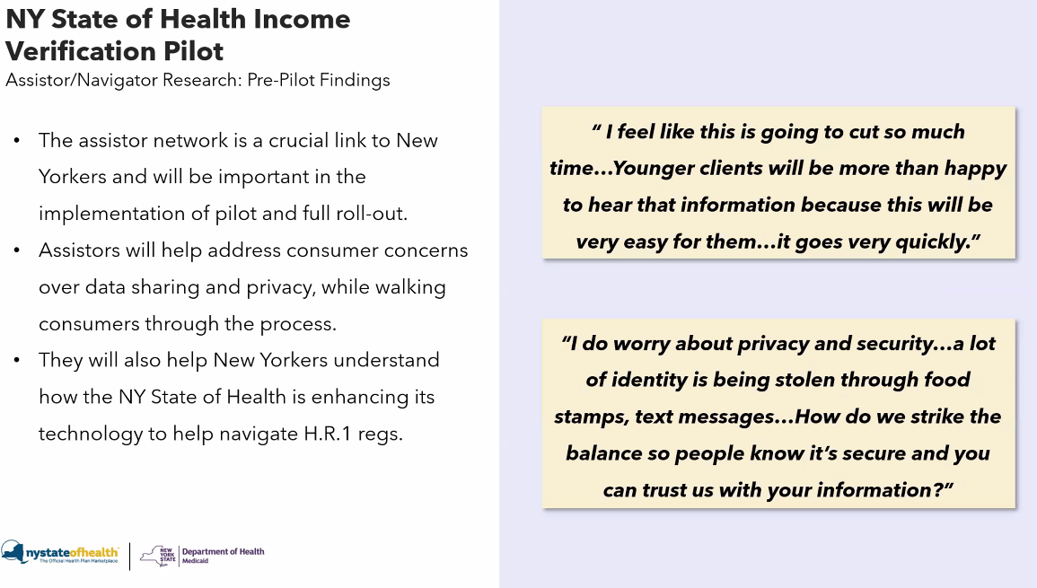
Assistors were positive about the opportunity to use TRUV. Also gave practical feedback on design.
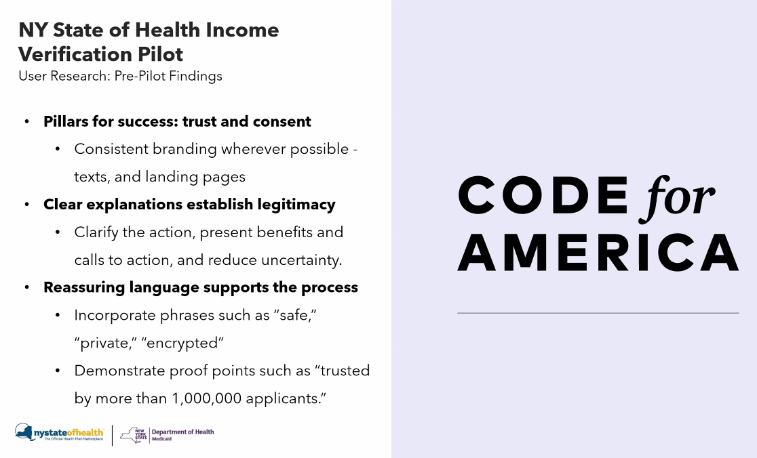
Spoke to ten Medicaid eligible consumers in NY to show them these elements of the program. Folks leaned on NYSOH branding to establish trust. Using cues to establish legitimacy.
Phrases like safe, private, proof, optional, etc. were helpful in establishing trust.

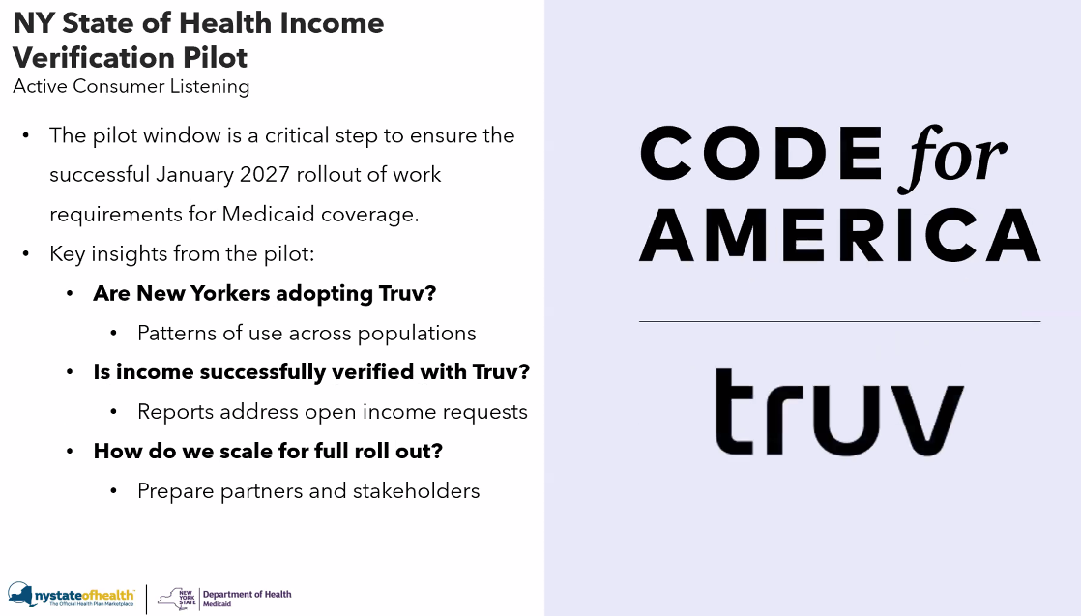

Pilot Phase 1 – Jul 23rd through august. First Impressions. Monitoring early usage. Are people flocking to TRUV? Pulling topline metrics, what percentage of people who are sent actually engage? Where do people drop off in the flow? What percentage complete it. Will reach out to call center staff to get direct feedback.
Pilot Phase 2: Deep dive. Analyze data from phase 1 holistically. How to improve on struggles identified. Understand client perspectives and what could be improved. Will focus demographically to if people use it.
Pilot Phase 3: understanding findings together. How can DOH scale it for Jan 2027 rollout. Impact – how will it save individuals and assistors time and effort? Consolidate those recommendations for future releases.

Question: How is NYS dealing with folks without access to a computer or gig workers?
NYS is developing this right now. TRUV is mobile first designed. Interface is intuitive once an employer is identified, with multiple options of how to log in. Another key is the assistor population. 80% of applicants go through assistors, so the state is training assistors in being comfortable and confident in the technology. Leaning on front line workers interfacing with applicants is critical to success.
Question: is the consent ongoing or limited to each renewal? What does it mean if a member reports an issue?
It depends – if your credentials change (login) you will have to consent again. Some limits depending on employer, how long the consent is valid. This is intended to help with an automated renewal. There is a balance of consenting upfront to the renewal that someone is facing. Not wanting to allow for TRUV to keep pinging their income without their continued consent.
Consulting with TRUV and other states who use it to get more information.
Question: how would it work with Self-employment, small businesses?
It’s not a 100% data source. TRUV can connect to payroll providers and banking institutions. When people have trust issues with using their banking institutions. NYS unlikely to connect to banks to start – but it could be explored as an option. There is also an option to manually submit documents in TRUV. There is access to data from top employers already available to NYS being used to develop the interface now.
Question: if a person has an issue with the platfom how is NYS handling it/
NY is working directly with the call center and on the backend processing the TRUV documents. From call center side of things, working closely to make sure they have similar but tailored training and guides around the technology. Call center will not have direct access to TRUV for security, but can walk someone through the steps to troubleshoot. Most issues should be solved with this help. If there is a bigger issue, NY can work with TRUV to identify pain points that stop people from using it.
If there is trouble logging in – you can go and click ‘forgot your password’ to reset login information.
If you click ‘report an issue’ what do you get? You’re able to say it’s not right, or im not working there, or the number is incorrect. For pilot, no income summary page will be shown.
Question: Who are the employers in TRUV? What about self-reporting through Venmo, Cashapp, Paypal?
For pilot, it’s a focus on the employer and the payroll company. Its income verification 1.0 – learning as much as possible right now. There will be other options for people to submit documents.
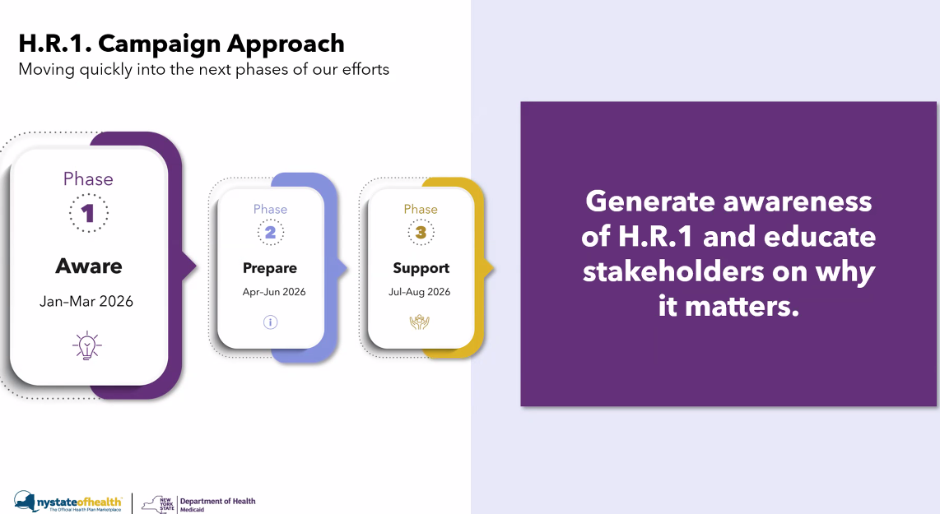
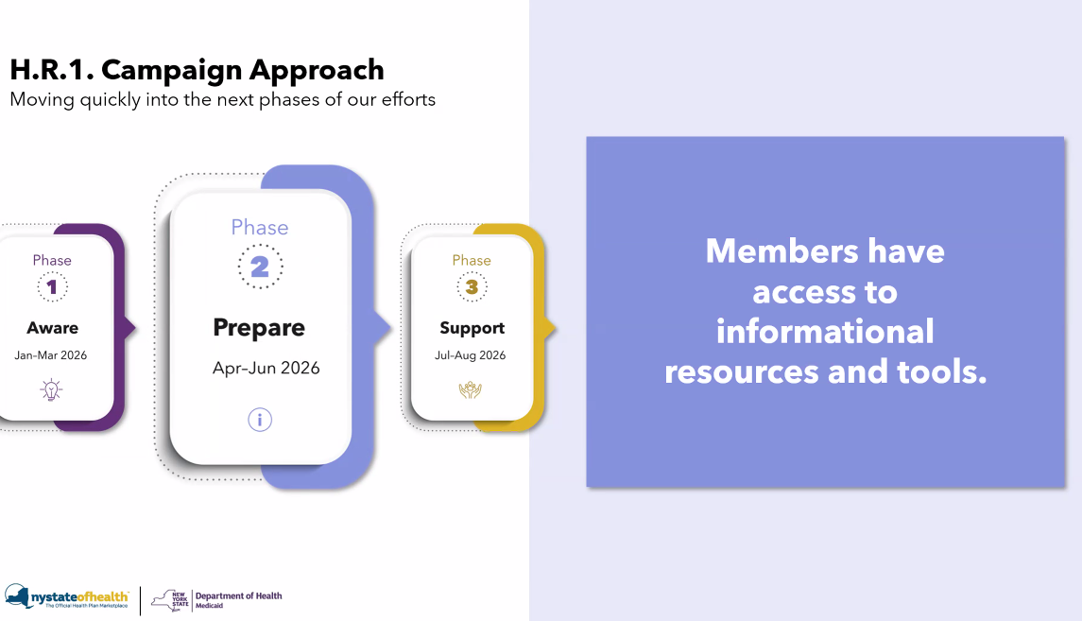
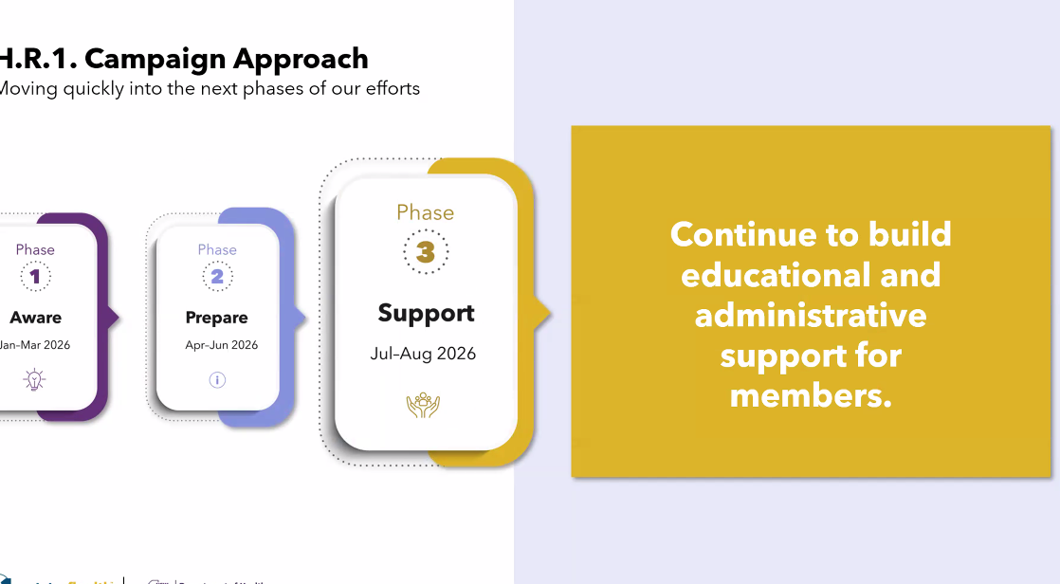
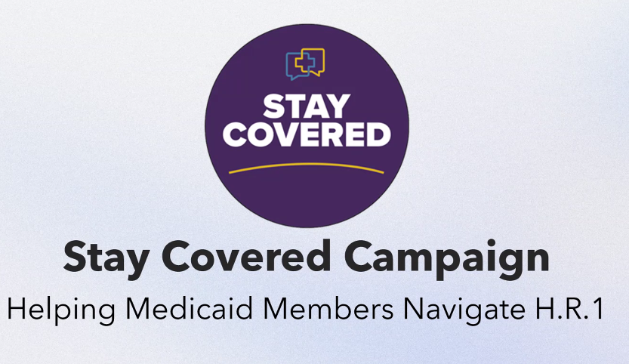
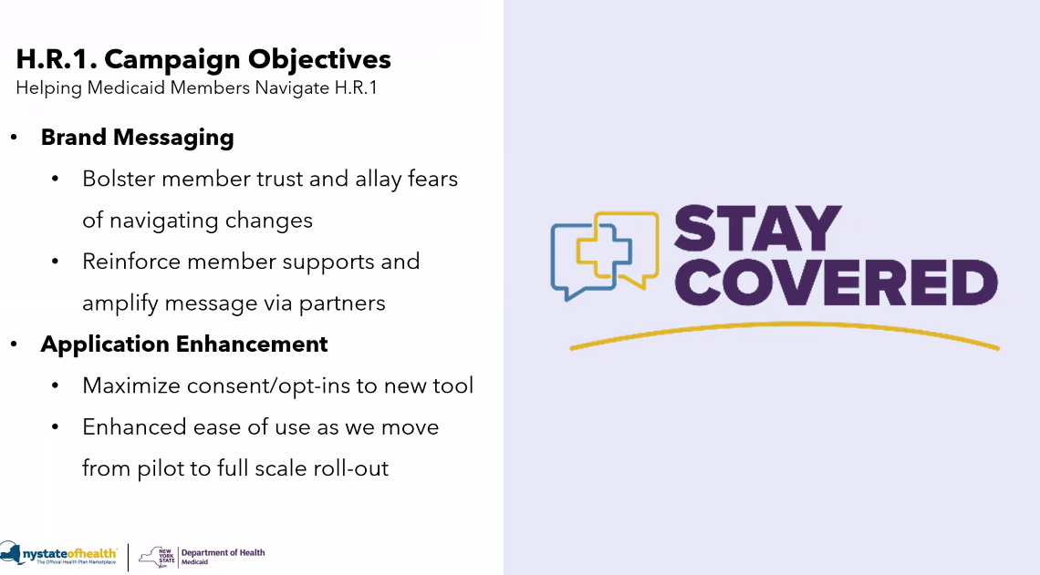
Brand message: building member trust around changes. Make sure they feel supported. Marketplace as a trusted brand – leveraging equity built up with consumers over the years.
NY is making a product enhancement to the application through TRUV – a part of the messaging is to maximize people’s time with a seamless experience. Dealing with two levels of consent, needing to opt in to the new tool. They need to do so in a trusted environment. Goal of campaign is to get people to use the tool.
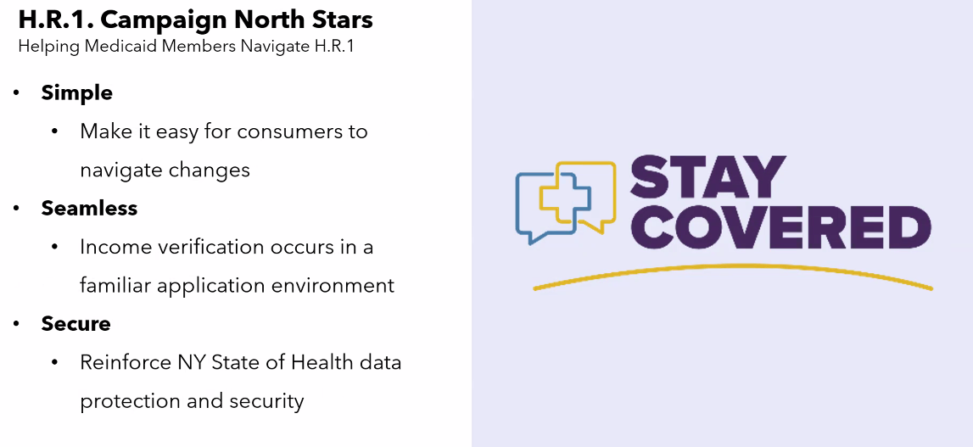
One question that has come up in the chat – how is NY casting a broad net? Everyone is working to figure out what they need to do. Its not just making sure everyone is talking about it, but that everyone is talking in the same way and the same voice across the state.
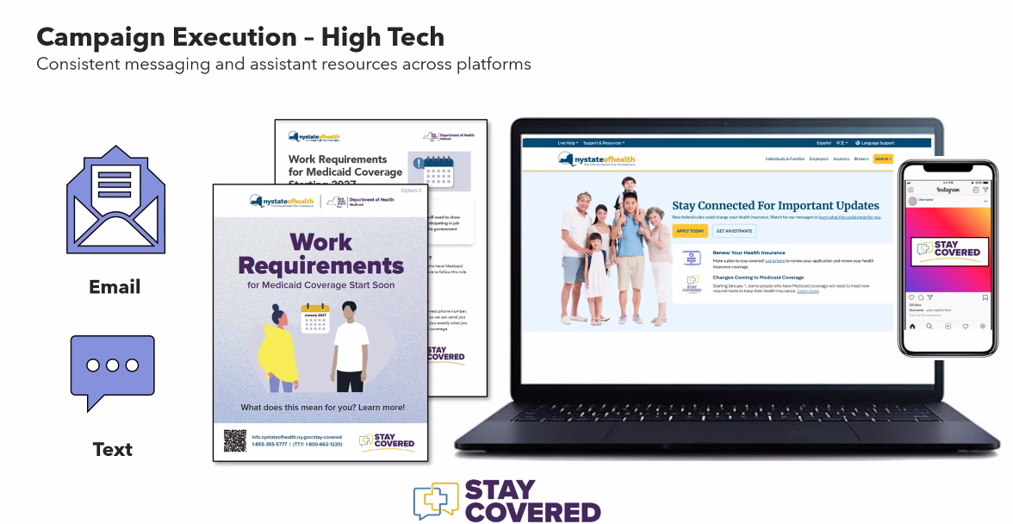
Materials and toolkits being made available to equip assistors and street teams and establishing a broad network with consistent messaging.
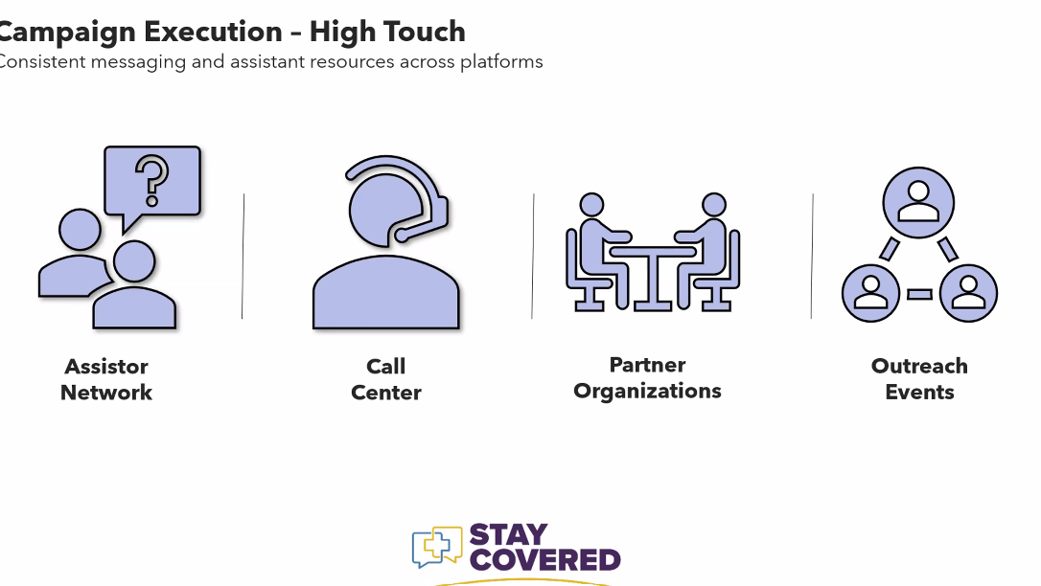
Community who relies on other people to help them do what they need to do. 80% use assistors. Making sure the assistors are well-equipped to navigate. Call center is a critical group for dealing with folks as they call in. Partner orgs will play a part. Going to where people go – going to be at events across the state.
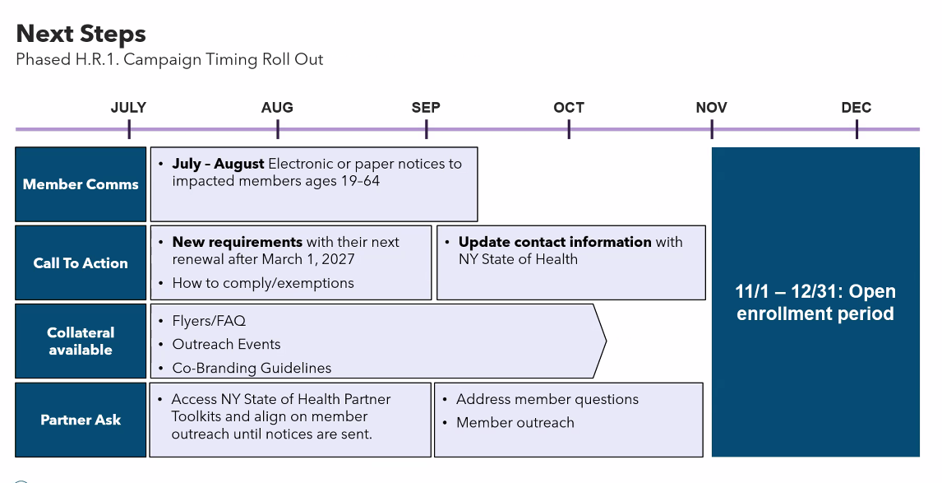
NY will continue to post info on its website. Still looking how to leverage messaging during open enrollment from Nov-Dec. Thinking about 2027 once full-scale rollout is in play.

